**5000 Series Solenoid Proportional Valve**

The Acequip 5000 series compact solenoid proportional valve, known for its low hysteresis flow control features, showcases exceptional performance in gas chromatographs and analytical instruments. This valve enables accurate and stable flow and pressure control, catering perfectly to precision control devices.

* Compliant with RoHS
* High performance proportional control technology
* Low power consumption (≤2W) low heat generation
* Butterfly spring design for fluid stability
* Small and compact design

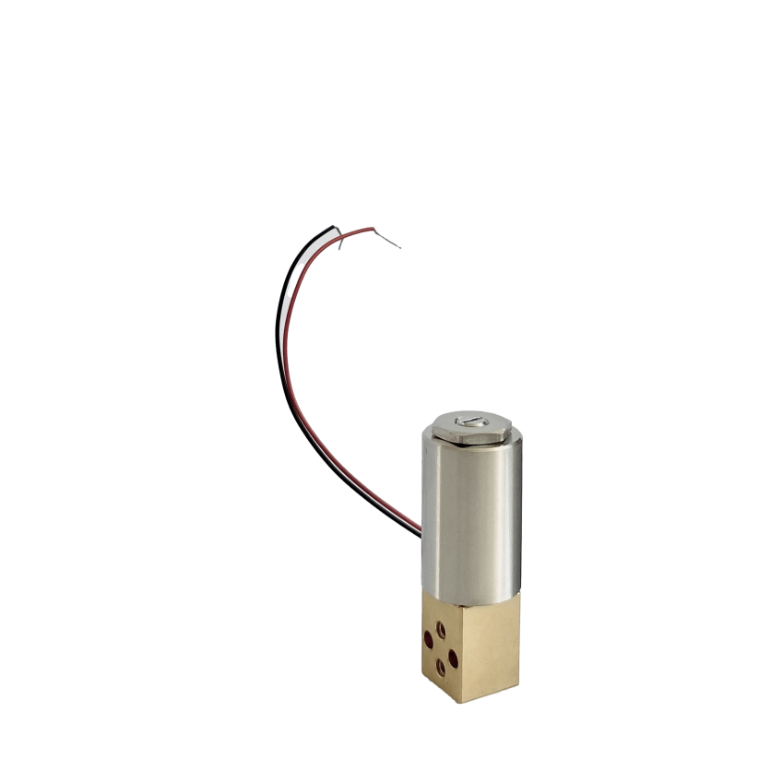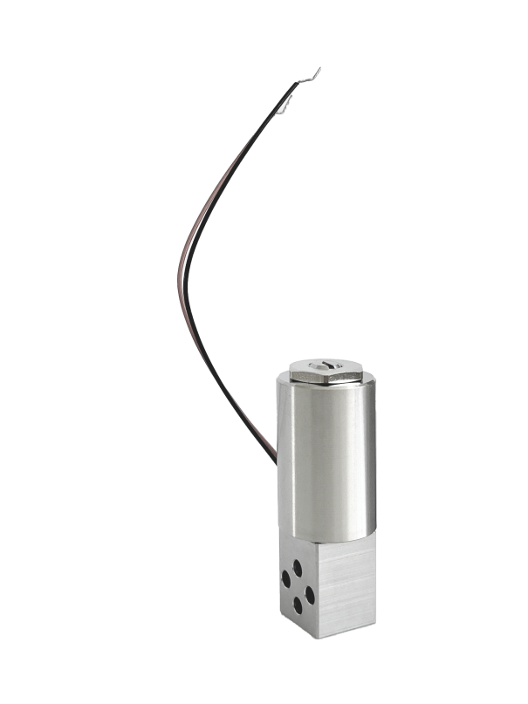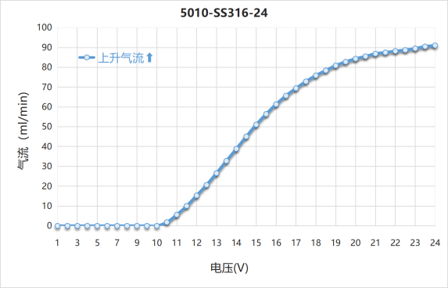

5000 Series-Brass

5000 Series-sus316

5010 Control Valve Characteristics

**Specifications**

|  |  |  |  |  |  |  |  |  |
| --- | --- | --- | --- | --- | --- | --- | --- | --- |
| **MODEL** | | **5005** | **5010** | **5015** | **5020** | **5025** | **5030** | **Note** |
| Flow Range (ml/min) | | 20 | 100 | 1000 | 4000 | 8000 | 16000 | Air calibration under 0.1mpa |
| Pressure | Proof Pressure | 980kPa | | | | | | Proof pressure is for valve main unit. In the case of the hose nipple type, refer to the proof pressure of the hose. |
| Operating differential Pressure | -0.98MPa | | | -0.6Mpa | -0.4MPa | |  |
| Control | Maximum control voltage | 12V/24V | | | | | |  |
| Power consumption | Max. 2W | | | | | |  |
| Hysteresis | 15% or less/full scale current | | | | | |  |
| Filter | | 20 μ (IN/OUT) | | | | Without filter | |  |
| Internal leak | | 0.1 ml/min or less within the proof pressure range of the gas | | | | 0.2ml/min or less | | Less leak rate on request |
| External leak(He) | | 1*10-9Pa.m³/s or less | | | | | |  |
| Operating temperature | | 0℃-50℃ | | | | | | The temperature coefficient of the coil copper wire resistance is 0.004. The resistance is obtained by: Rt = R0°C (1 + 0.004 × t°C). When using  voltage control, make sure that the ambient temperature does not vary widely. Otherwise current control is recommended. |
| Storage temperature | | -5℃-70℃ | | | | | |  |
| Wetted material | BS | C3604、SUS430F、VITON、SUS316、SUS304 | | | | | |  |
| SUS | SUS430F、VITON、SUS316、SUS304 | | | | | |  |
| Dimensions (mm) | | □13×17.5+∅19×31 | | | | | |  |
| Lead wire | | UL3266 XLPE＃28 | | | | | |  |
| Insulation | | Class A | | | | | |  |
| Connection end | | φ3.0 (standard), φ3.0Hose nipple, Rc1/8 | | | | | |  |
| Weight | | Approx. 60g (The type with Rc 1/8: 180g) | | | | | |  |

**Model Selections**

* Example： 5010-BS-15-D3-S
* More request pls consult with your sales representative.

5005

5010

5015

5020

5025

5030

Model

Material

BS: Brass

SS316: 316

Power

15: 15V

24: 24V

Connection

B: φ3.0

D3: φ3 hose nipple

RC8: Rc 1/8

X: Other request

Standard

S: Standard

X: Other request

**Dimensions (φ3.0 ring manifold)（mm）**

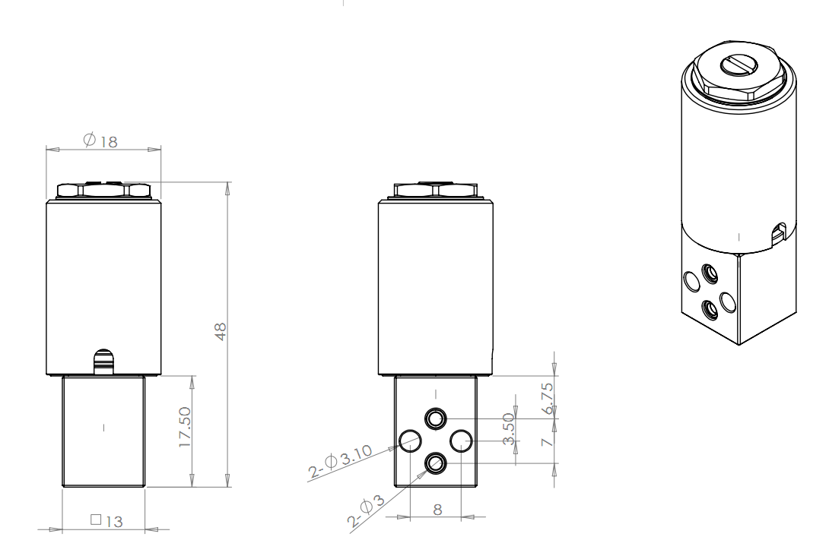

**Dimensions (With Rc 1/8 block)（mm）**

