**6000 Series Solenoid Proportional Valve**

Acequip 6000 series solenoid proportional valve features a viton seal design and offers efficient regulation of fluid pressure and flow by adjusting the input voltage. With fast response, low power consumption, and low heat generation, this valve is ideal for industrial automation systems and various other fields. Experience high-precision fluid control for enhanced system stability and efficiency.

* Compliant with RoHS
* Low power consumption, low heat generation
* Excellent corrosion-resistance, perfect in hysteresis loss
* External Leak(He) ：＜1*10-9Pa.m³/s
* Fast Response

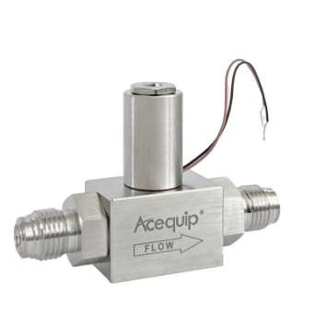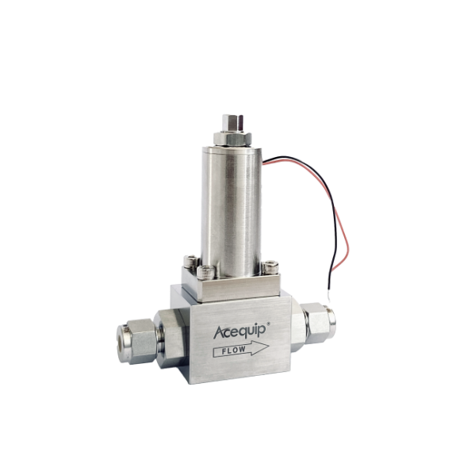

6005/6010/6015/6020/6025/6030

6045/6050/6055 Series

6045流量控制特性图

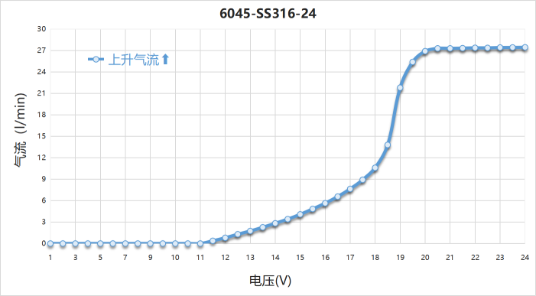

**Specifications（Low Flow Model：20SCCM~16SLM）**

We have many brochure templates that has been specifically designed to help anyone that is stepping into the world of WPS Office for the very first time.

|  |  |  |  |  |  |  |  |  |
| --- | --- | --- | --- | --- | --- | --- | --- | --- |
| **MODEL** | | **6005** | **6010** | **6015** | **6020** | **6025** | **6030** | **Note** |
| Max Flow Range (SCCM) | | Low Flow | | | | | | Same Size |
| 20 | 100 | 1000 | 4000 | 8000 | 16000 | Air calibration at 0.1 MPa |
| Pressure | Proof Pressure | 980kPa | | | | | |  |
| Operating differential Pressure | ＜0.98MPa | | | ＜0.6MPa | ＜0.4MPa | |  |
| Control | Maximum control voltage | 12V/24V | | | | | |  |
| Power consumption | Max 2W | | | | | |  |
| Filter | | 800 mesh stainless steel (Inlet) | | | | | | Filter for outlet on request |
| Internal Leak | | 0.1 ml/min or less within the proof pressure range of the gas | | | | | | Less leak rate on request |
| External leak(He) | | Less than 1*10-9Pa.m³/s | | | | | |  |
| Temperature | | 0℃-50℃ | | | | | | The temperature coefficient of the coil copper wire resistance is 0.004. The resistance is obtained by: Rt = R0°C (1 + 0.004 × t°C). When using voltage control, make sure that the ambient temperature does not vary widely. Otherwise current control is recommended. |
| Storage temperature | | -5℃-70℃ | | | | | |  |
| Wetted materials | | VITON、SUS316、Electromagnetic SS | | | | | |  |
| Wire | | UL3266 XLPE＃28 | | | | | |  |
| Insulation Classes | | Class A | | | | | |  |
| Connections | | 1/4''Lok or 1/4"VCR | | | | | |  |
| Weight | | About 245g | | | | | |  |

**Specifications（Medium Flow：28SLM~56SLM）**

|  |  |  |  |  |  |
| --- | --- | --- | --- | --- | --- |
| **MODEL** | | **6045** | **6050** | **6055** | **Note** |
| Max Flow Range (SLM) | | Medium Flow | | | Same Size |
| 28 | 43 | 56 | Air calibration at 0.1 MPa |
| Pressure | Proof Pressure | 980kPa | | |  |
| Operating differential Pressure | ＜0.5MPa | | |  |
| Control | Maximum control voltage | 12V/24V | | |  |
| Power consumption | Max 2.5W | | |  |
| Filter | | 800 mesh stainless steel (Inlet) | | | Filter for outlet on request |
| Internal Leak | | 0.1 ml/min or less within the proof pressure range of the gas | | | Less leak rate on request |
| External leak(He) | | Less than 1*10-9Pa.m³/s | | |  |
| Temperature | | 0℃-50℃ | | | The temperature coefficient of the coil copper wire resistance is 0.004. The resistance is obtained by: Rt = R0°C (1 + 0.004 × t°C). When using voltage control, make sure that the ambient temperature does not vary widely. Otherwise current control is recommended. |
| Storage temperature | | -5℃-70℃ | | |  |
| Wetted materials | | VITON、SUS316、Electromagnetic SS | | |  |
| Wire | | UL3266 XLPE＃28 | | |  |
| Insulation Classes | | Class A | | |  |
| Connections | | 1/4''Lok or 1/4"VCR | | |  |
| Weight | | About 465g | | |  |

**Model Selection**

6005：0-20 SCCM

6010：0-100 SCCM

6015：0-1000 SCCM

6020：0-4000 SCCM

6025：0-8000 SCCM

6030：0-16000 SCCM

6045: 0-28 SLM

6050: 0-43 SLM

6055: 0-56 SLM

Model

Material

SS304: 304

SS316: 316

Voltage

12: 12V

24: 24V

Connections

B: Non

E4S: 1/4''LOK

E4V: 1/4''VCR

X: Customized

Max Flow

20 SCCM

100 SCCM

1000 SCCM

4000 SCCM

8000 SCCM

16000 SCCM

28 SLM

43 SLM

56 SLM

* Example： 6010-SS316-12-E4S-100SCCM
* For more customized models, pls consult with the sales representative.

**Low Flow Model (Non Connections) Dimensions（mm）**

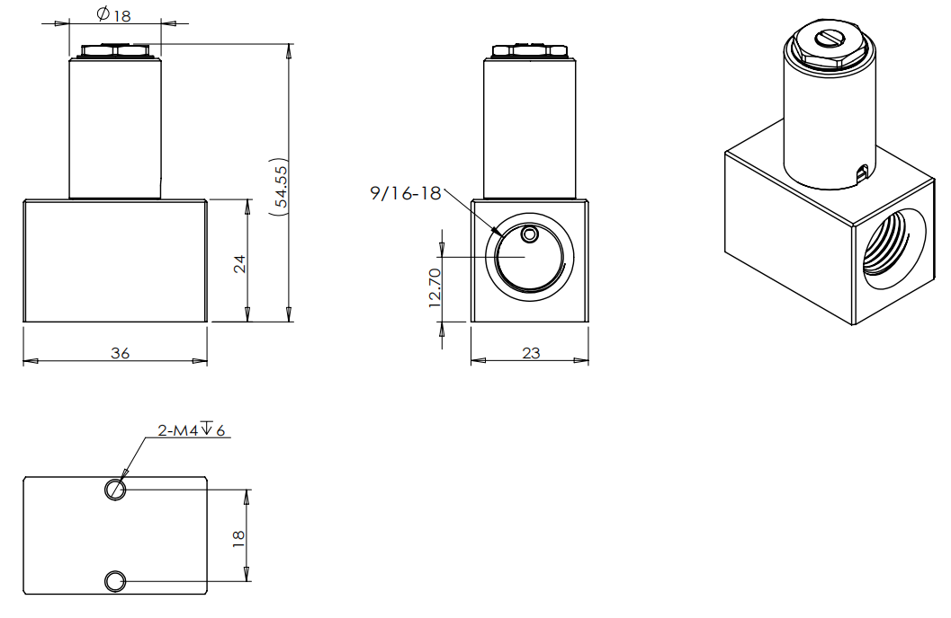

**Low Flow Model (1/4” LOK) Dimensions（mm）**

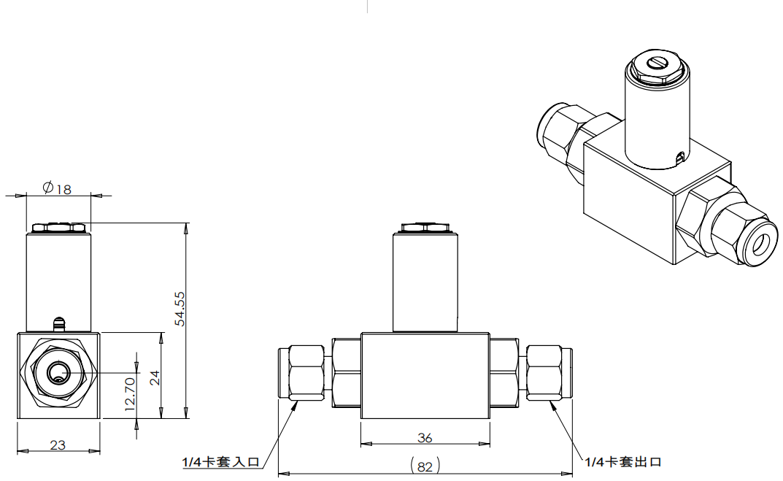

**Medium Flow Model (Non Connections) Dimensions（mm）**

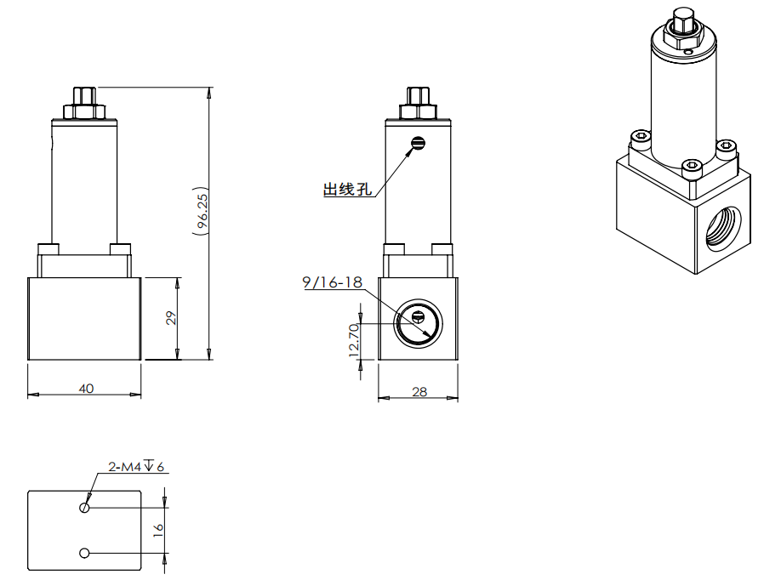

**Medium Flow Model (1/4” LOK) Dimensions（mm）**

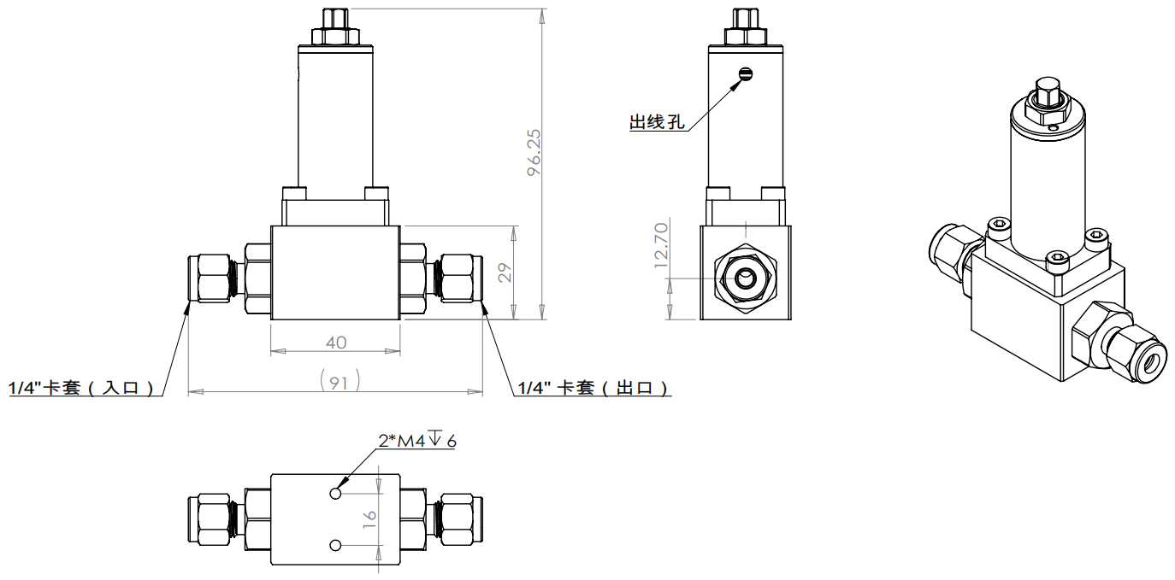

**Medium Flow Model (1/4” VCR) Dimensions（mm）**

