**7000 Series Solenoid Proportional Valve**

Acequip 7000 series metal-sealed solenoid proportional valves with exceptional sealing and corrosion resistance. These valves utilize high-purity metal sealing materials to minimize particulate matter and residual pollutants, reducing equipment failure rates and ensuring long-term efficiency. Leakage rate lower than 1*10-11Pa.m³/s. Offering both teflon-metal seal (70-) and all-metal seal (71-) specifications to meet different application requirements.

* Compliant with RoHS
* Optional Teflon metal seal (70-) and all metal seal (71-)
* Maximum flow range: 0-200 l/min
* Leakage rate: ＜1*10-11Pa.m³/s

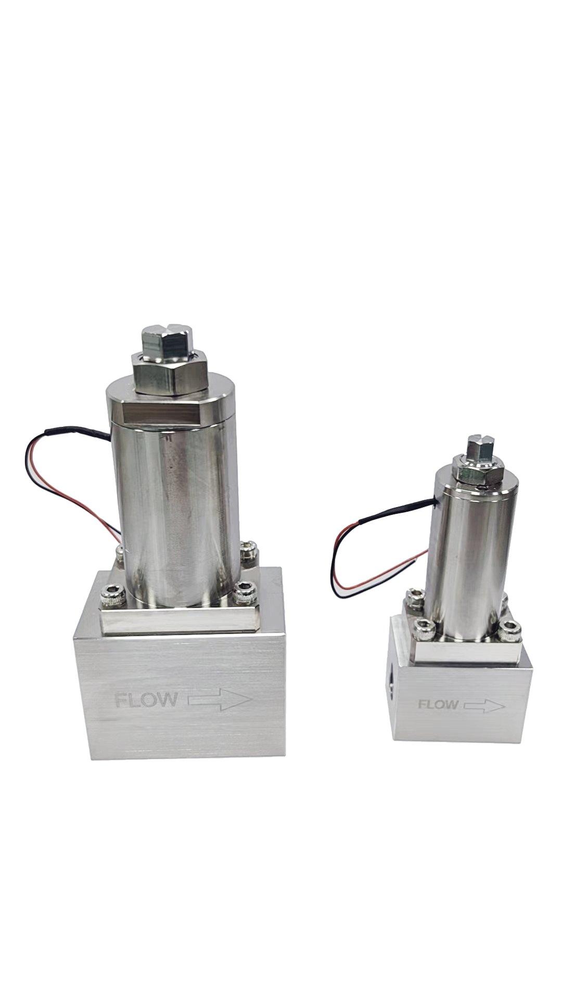

7000 Series

**型号选择Model Selection**

70（71）45: 0-25 SLM

50: 0-43 SLM

55: 0-55 SLM

60: 0-115SLM

65: 0-150SLM

70: 0-200SLM

Model

Material

SS316: 316

Power

12: 12V

24: 24V

Connection

E4V: 1/4''VCR

E6V: 3/8" VCR

X: 定制型号

Max Flow

25 SLM

43 SLM

55 SLM

115 SLM

150 SLM

200 SLM

* Teflon型金属密封 型号示例： 7045-SS316-12-E4S-25SLM
* 全金属密封型号示例： 7145-SS316-12-E4S-25SLM
* 如需定制，X的具体数值请咨询销售代表。

**Specifications**

|  |  |  |  |  |  |  |  |  |  |  |
| --- | --- | --- | --- | --- | --- | --- | --- | --- | --- | --- |
| **MODEL** | | **7000 Series** | | | | | | | | **Note** |
| Size | | Medium Flow | | | | | High Flow | | | Same Size |
| Model | Teflon Metal Seal | 7045 | 7050 | 7055 | | 7060 | | 7065 | 7070 | Air calibration at 0.1 MPa |
| All Metal Seal | 7145 | 7150 | 7155 | | 7160 | | 7165 | 7170 |
| Max Flow(SLM) | | 0-25 | 0-43 | 0-55 | | 0-115 | | 0-150 | 0-200 |
| Operating differential pressure | | 0-0.6MPa | | | | | 0-0.4MPa | | |  |
| Proof Pressure | | 1MPa | | | | | | | |  |
| Control | Control Voltage  (Max) | 12V/24V可选 | | | | | | | | DC直流 |
| Power Consumption | Max 2.5W | | | | | | | |  |
| Filter | | 800 mesh stainless steel (Inlet)  (Filter for outlet on request) | | | | | | | |  |
| Internal leak | | ＜0.1 ml/min or less | | | | | | | | within the proof pressure range of the gas |
| External Leak(He) | | 1*10-11Pa.m³/s以下 | | | | | | | |  |
| Operating temperature | | 0℃-50℃ | | | | | | | | The coil's copper resistance follows Rt = R0°C (1 + 0.004 × t°C). For voltage control, maintain a stable ambient temperature; otherwise, use current control. |
| Storage temperature | | -5℃-70℃ | | | | | | | |  |
| Wetted Material | Teflon Metal Seal | 70-: PTFE、SUS316、Electromagnetic stainless steel | | | | | | | |  |
| All Metal Seal | 71-: PTFE、SUS316、Electromagnetic stainless steel | | | | | | | |
| Connections | | 1/4"VCR or 3/8"VCR | | | | | | | | More options |
| Weight | | About 523g | | | About 1356g | | | | | Fittings included |

**7000 Series Medium Flow Solenoid Proportional Valve**

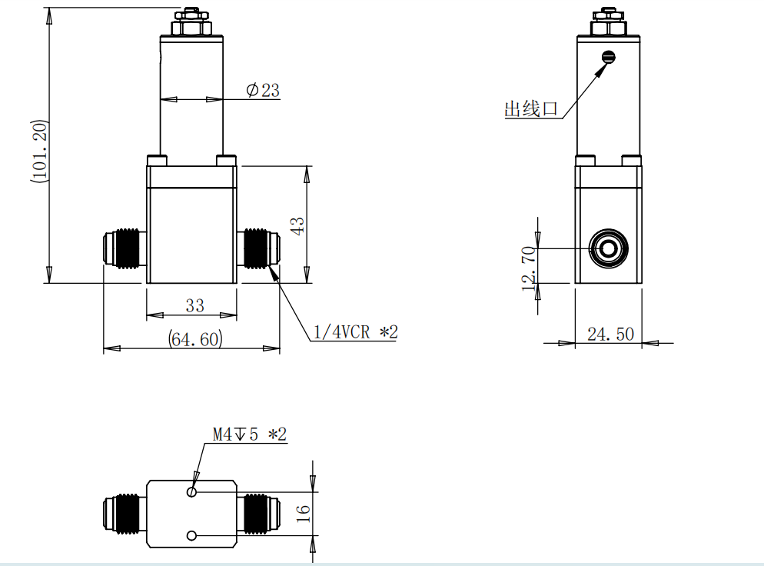

**7000 Series High Flow Solenoid Proportional Valve**

