**VSP-1A Proportional Valve Driver**

The Acequip VSP-1A is a high-performance proportional valve driver designed to enhance precision, efficiency, and control stability in fluid and gas flow systems. Engineered for seamless integration with Acequip 5000, 6000, and 7000 series proportional valves, it significantly reduces development time while enabling highly responsive PID control in On-Board and PLC-based applications.

### ****Advanced Control & Versatile Compatibility****

Supporting industry-standard 0-5V, 0-10V, 0-2.5V, and 0-20mA control signals, the VSP-1A adapts to a wide range of automation and industrial control systems. Its high-precision signal amplification and filtering technology minimize noise interference, ensuring smooth and accurate valve actuation.

### ****Enhanced Resolution & Performance Optimization****

Equipped with an adjustable potentiometer, the VSP-1A eliminates dead-band voltage, significantly improving resolution and control sensitivity. Its internal amplifier dynamically boosts control signals, guaranteeing stable and responsive valve operation under varying load conditions. With a wide 8–32V DC input range, the driver maintains consistent performance across diverse power environments. To ensure maximum efficiency, a power supply at least 1V above the valve’s requirement is recommended.

### ****Intelligent Tuning & Adaptive Adjustments****

The VSP-1A incorporates an intelligent switching mechanism to enhance proportional valve response. By compensating for the solenoid’s minimum turn-on voltage, it prevents unnecessary delays and optimizes control precision. The onboard switch enables users to bypass dead-band voltage, ensuring smoother flow modulation and finer control accuracy

### 1732697187957

### ****Reliable Integration & Simplified Deployment****

Preconfigured for effortless installation, the VSP-1A minimizes setup complexities, accelerating deployment while ensuring long-term reliability. Its robust design, combined with intelligent control features, makes it an essential component for achieving precision-driven proportional valve control in industrial automation, fluid management, and analytical instrumentation applications.

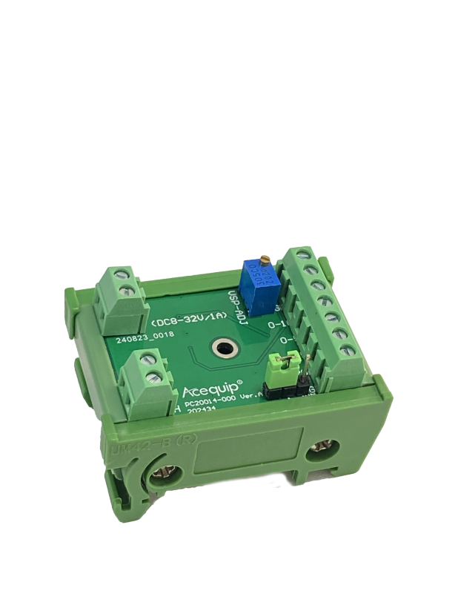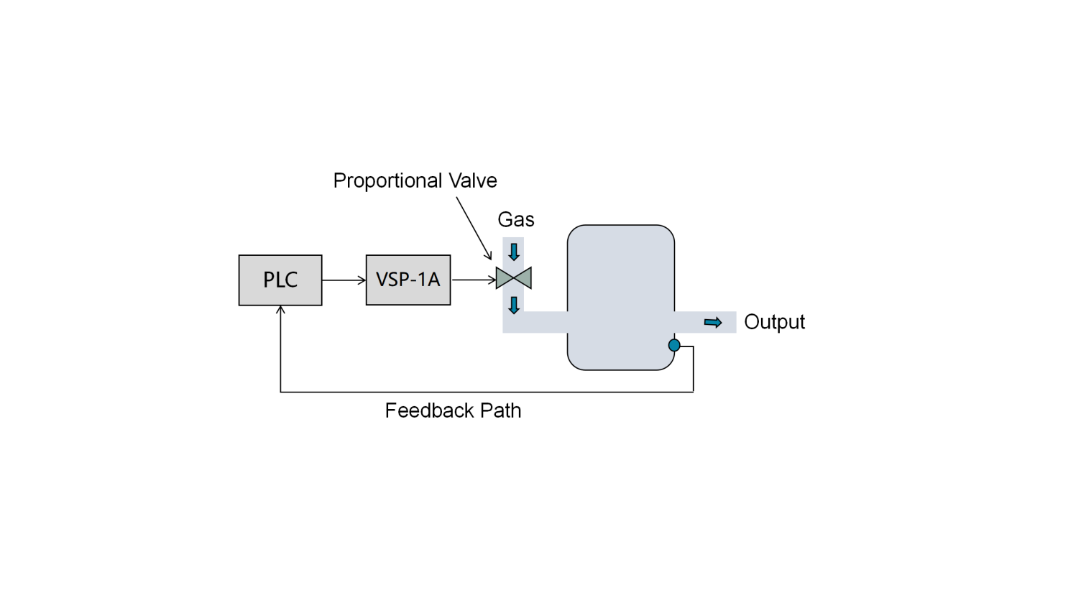

**闭环控制系统**

**Basic closed loop system**

**比例阀驱动器VSP-1A**

**Solenoid Valve Driver VSP-1A**

**Specifications**

**Dimensions**

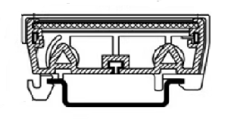

48.4mm

23.6mm

35mm