Acequip A1 Analog (0-5V) MFC

A1-FCRANCV/A1-FCRAVCV

**Product Description**

Mass Flow Controller of A1-FCRANCV/A1-FCRAVCV is designed to deliver reliable, high-performance flow control, making it the ideal solution for industrial applications seeking precision and cost-efficiency. With optimized technology for superior performance, this product offers a versatile and durable option for your flow control needs.

**Key Features:**

* **Wide Flow Range:** From 10 SCCM (milliliters per minute) to 30 SLPM (liters per minute), accommodating a wide range of flow applications.
* **Flexible Power Options:** Dual power supply (±15VDC) or wide voltage range (+12VDC to +32VDC) to suit different system requirements.
* **Easy Installation:** Integrated connector base design allows installation in any orientation for maximum flexibility.
* **Flow Stability:** Suppresses flow overshoot during startup to ensure smooth and precise control.
* **Signal Compatibility:** Supports analog signals (0-5VDC) for seamless communication with your system.
* **Low Leak Rate:** Maximum leak rate of 1x10-9 Pa·m³/sec (He), ensuring minimal gas loss and high operational efficiency.

**Specifications**

|  |  |
| --- | --- |
| Model | A1 |
| Full Scale Range(N2 eqv) | 10 SCCM – 30 SLM |
| Response Time | ≤1.5 sec |
| Accuracy | ≤ ±1% of Full Scale |
| Linearity | ≤ ±0.5% of Full Scale |
| Repeatability | ±0.1% of Full Scale |
| Operating Differential Pressure | 0.05 - 0.28 MPa |
| Leak Integrity | Max 1x10-9Pa.m3/sec (He) |
| Control Range | 2-100% of Full Scale |
| Max operating Pressure | 0.48 MPa |
| Proof Pressure | 1 MPa |
| Operation Temperature | 5-45 Deg C |

|  |  |
| --- | --- |
| Control Valve | Normally closed/Normally Open Solenoid Valve |
| Fitting | 1/4"VCR or 1/4" Swagelok Compatible |
| Seal | Viton Seal |
| Orientation | Free |
| Wetted Material | SUS316L, Viton, PTFE, Electromagnetic stainless steel |
| Surface Finish | ≤5RA |
| Weight | appr. 0.8 KG |

**Mechanical**

|  |  |  |
| --- | --- | --- |
| Analog Input Voltage | DC 0-5V | |
| Analog Output Voltage | DC 0-5V | |
| Power Supply | ±15VDC | +15VDC ±2% 25mA |
| -15VDC ±2% 180mA |
| +12VDC-+32VDC | +12VDC 500mA - +32VDC 180mA |
| Power Consumption | ±15VDC | 3.1W |
| +12VDC- +32VDC | 6W |
| Connector | 9Pin D-sub Male | |

**Electrical**

**Dimensions**

Acequip A1 Analog（0-5V）Mass Flow Controller

A1-FCRANCV-E4S/A1-FCRAVCV-E4S (1/4”LOK)

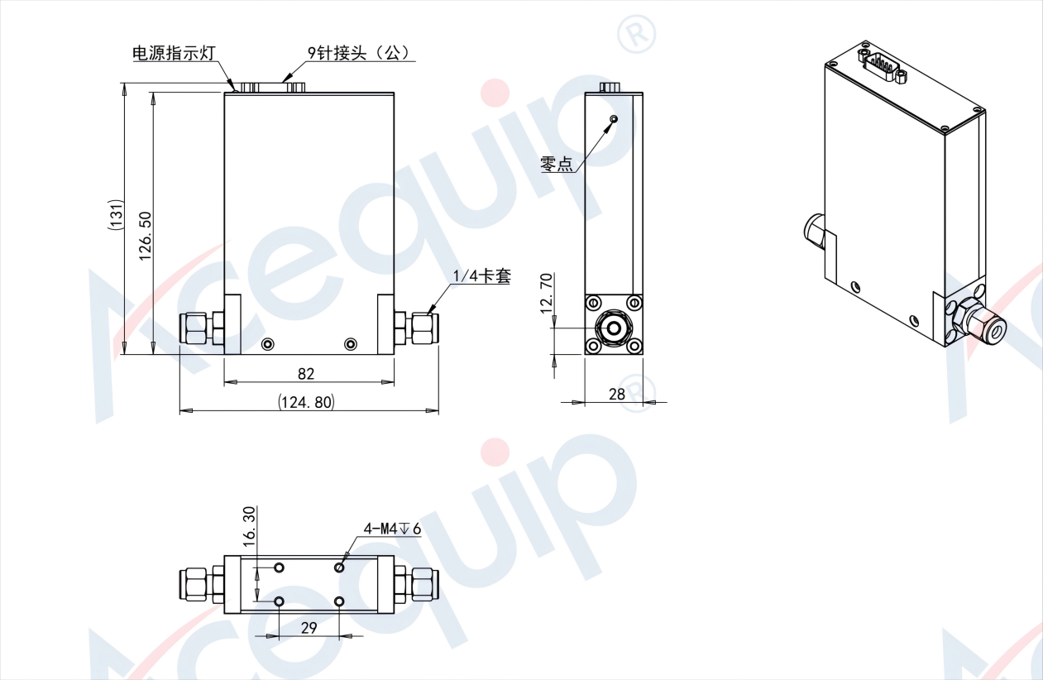

Acequip A1 Analog（0-5V）Mass Flow ControllerA1-FCRANCV-E4V/A1-FCRAVCV-E4V (1/4”M.VCR)

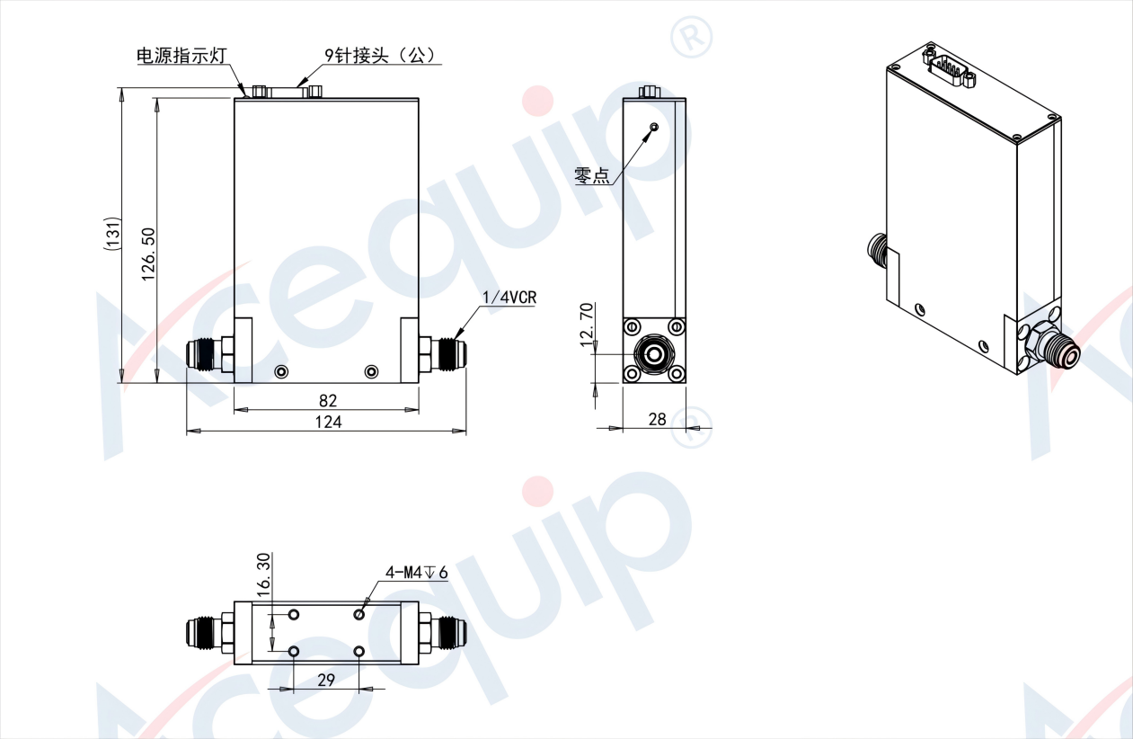

Acequip A1 Analog（0-5V）Mass Flow Controller A1-FCRANCV-G6S/A1-FCRAVCV-G6S (6mm LOK)

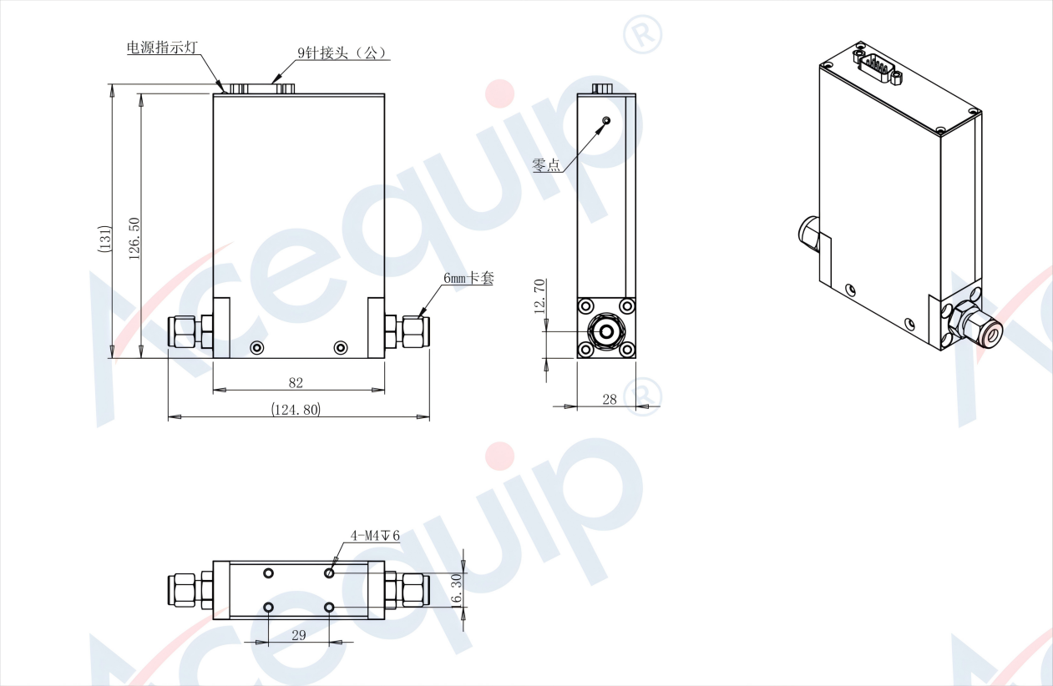

**Part Number Identification**

Acequip A1 Analog（0-5V）Mass Flow Controller

