Acequip Analog（4-20mA）MFC

A1-FCRAVCI

**Product Description**

The A1-FCRAVCI is an advanced 4-20mA analog Mass Flow Controller designed to provide reliable flow control and precise measurement in industrial applications. Featuring an optimized design for improved performance, it ensures high accuracy and reliability, offering a cost-effective solution for efficient flow regulation.

**Key Features:**

* **Wide Flow Range:** From 10 SCCM (milliliters per minute) to 30 SLPM (liters per minute), accommodating a wide range of flow applications.
* **Power Supply:** Wide voltage range (+12VDC to +32VDC)
* **Easy Installation:** Integrated connector base design allows installation in any orientation for maximum flexibility.
* **Flow Stability:** Suppresses flow overshoot during startup to ensure smooth and precise control.
* **Signal Compatibility:** Supports analog signals (4-20mA)
* **Low Leak Rate:** Maximum leak rate of 1x10-9 Pa·m³/sec (He), ensuring minimal gas loss and high operational efficiency.

**Specifications**

|  |  |
| --- | --- |
| Model | A1 |
| Full Scale Range(N2 eqv) | 10 SCCM – 30 SLM |
| Response Time | ≤1.5 sec |
| Accuracy | ≤ ±1% of Full Scale |
| Linearity | ≤ ±0.5% of Full Scale |
| Repeatability | ±0.1% of Full Scale |
| Operating Differential Pressure | 0.05 - 0.28 MPa |
| Leak Integrity | Max 1x10-9Pa.m3/sec (He) |
| Control Range | 2-100% of Full Scale |
| Max operating Pressure | 0.48 MPa |
| Proof Pressure | 1 MPa |
| Operation Temperature | 5-45 Deg C |

|  |  |
| --- | --- |
| Control Valve | Normally closed/Normally Open Solenoid Valve |
| Fitting | 1/4"VCR or 1/4" Swagelok Compatible |
| Seal | Viton Seal |
| Orientation | Free |
| Wetted Material | SUS316L, Viton, PTFE, Electromagnetic stainless steel |
| Surface Finish | ≤5RA |
| Weight | appr. 0.8 KG |

**Mechanical**

|  |  |  |
| --- | --- | --- |
| Analog Input Voltage | 4-20mA | |
| Analog Output Voltage | 4-20mA | |
| Power Supply | +12VDC 500mA - +32VDC 180mA | |
| Power Consumption | +12VDC- +32VDC | 6W |
| Connector | 9Pin D-sub Male | |

**Electrical**

**Dimensions**

Acequip Analog（4-20mA）Mass Flow Controller

A1-FCRAVCI-E4S (1/4”LOK)

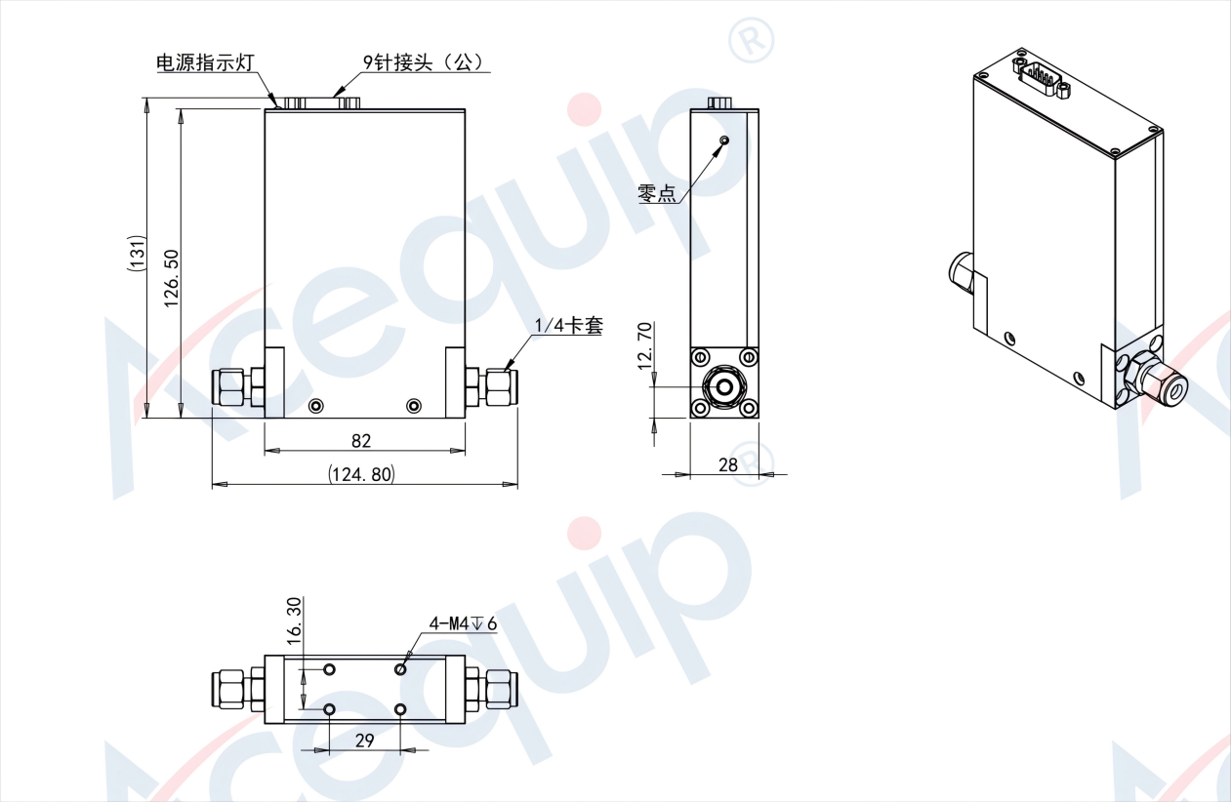

Acequip Analog（4-20mA）Mass Flow Controller

A1-FCRAVCI-E4V (1/4”M.VCR)

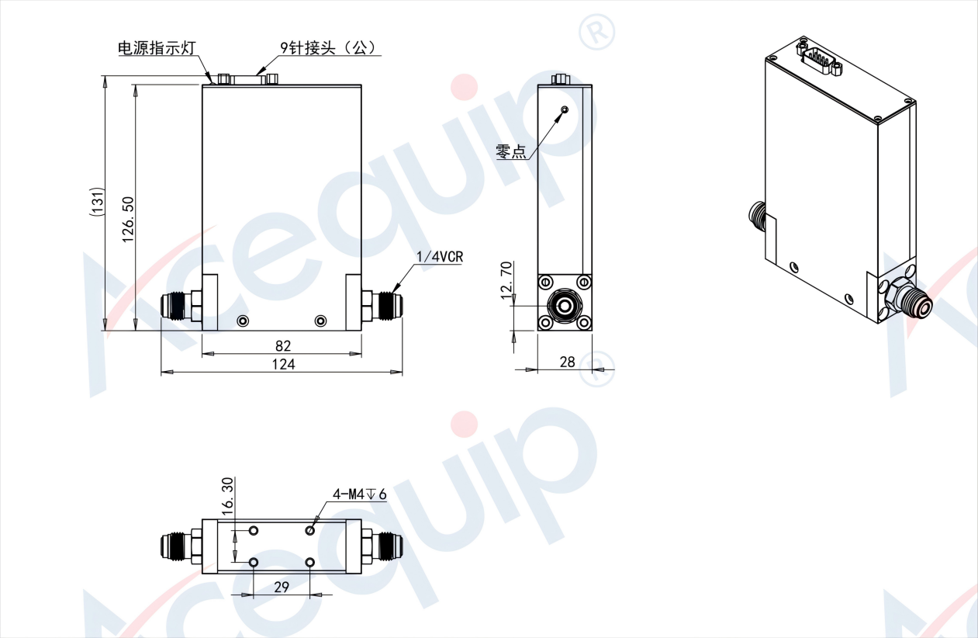

Acequip Analog（4-20mA）Mass Flow Controller

A1-FCRAVCI-G6S (6mm LOK)

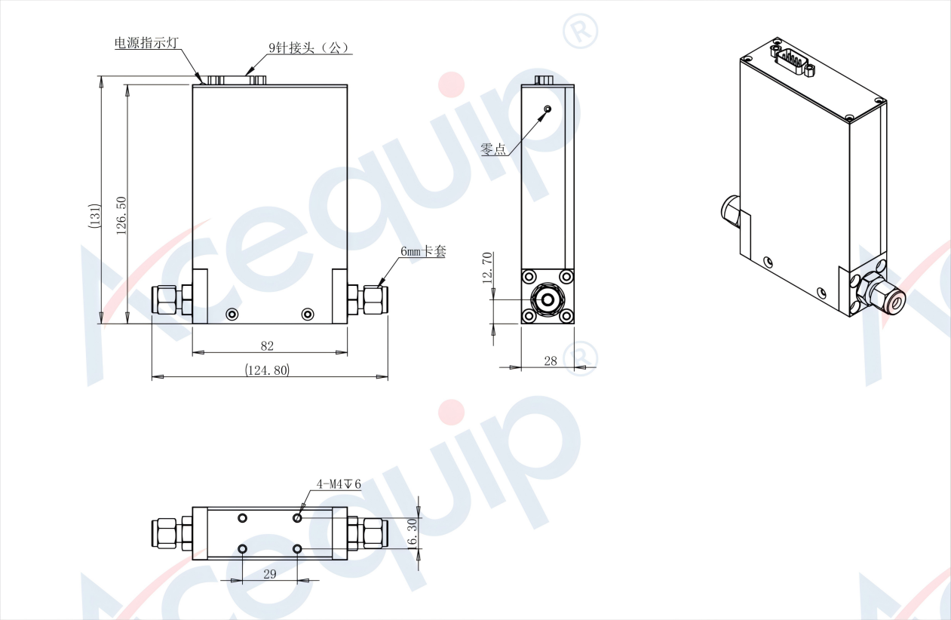

**Part Number Identification**

Acequip Analog（4-20mA）Mass Flow Controller

A1-FCRAVCI

