Acequip Digital（RS-485）MFC/MFM

A2-FCRRNCS/A2-FCRRVCS/A2-FMRRNS/A2-FMRRVS

**Product Description**

This high-performance digital mass flow controller (MFC) with RS-485 communication is engineered to deliver exceptional precision, flexibility, and reliability in gas flow control applications. Featuring an advanced high-accuracy flow sensor, this MFC provides a precision range of ±1% of the setpoint (S.P.). Combining advanced technology with a robust design, this MFC is perfectly suited for applications in semiconductor manufacturing, chemical processing, and research, meeting the highest standards of performance and reliability.

Features:

Available flow range from 2 sccm (milliliters per minute) to 50 slpm (liters per minute).

* Two types of control power supply: Dual power supply (±15VDC) or wide voltage range (+12VDC to +32VDC).
* RS-485 digital communication interface, supporting both ASCII communication protocol and Modbus RTU protocol.
* Analog input/output signal: 0 to 5 VDC.

Leak rate: Max 1x10^-9 Pa·m³/sec (He).

Configurable Options:

Multi-gas / multi-range configuration available.

Configurable multifunctional LCD local display control interface.

**Specifications**

|  |  |
| --- | --- |
| Model | A2 |
| Full Scale Range(N2 eqv) | 2 SCCM - 50SLM |
| Response Time | ≤ 0.8 sec |
| Accuracy | ≥25% F.S. ：≤±1% S.P. |
| ＜25% F.S. ：≤± 0.25% F.S. |
| Linearity | ≤ ±0.5% of Full Scale |
| Repeatability | ≤ ±0.1% of Full Scale |
| Operating Differential Pressure | 2 SCCM – 10 SCCM：0.05 - 0.28 MPa |
| 6 SLM – 50 SLM：0.1 – 0.28 MPa |
| Leak Integrity | Viton Seal: Max 1x10-9Pa.m3/sec (He) |
| Metal/All Metal Seal: Max 1x10-11Pa.m3/sec (He) |
| Control Range | Single Gas： 2-100% of Full Scale |
| Multi Gas Multi Range：5-100% of Full Scale |
| Max operating Pressure | 0.48 MPa |
| Proof Pressure | 1 MPa |
| Operation Temperature | 5-45 Deg C |

|  |  |  |
| --- | --- | --- |
| Control Valve | Normally closed/Normally Open Solenoid Valve | |
| Fitting | 1/4"VCR or 1/4" Swagelok Compatible | |
| Seal | Viton Seal/Metal Seal/All Metal Seal | |
| Orientation | Free | |
| Wetted Material | Viton Seal：SUS316L, Viton, PTFE, Electromagnetic stainless steel | |
| Metal Seal：SUS316L, Ni, PTFE, Electromagnetic stainless steel | |
| All Metal Seal：SUS316L, Ni, Electromagnetic stainless steel | |
| Surface Finish | Viton Seal | ≤5RA |
| Metal Seal | TC，≤5RA |
| Weight | appr. 0.8 KG | |

**Mechanical**

**Electrical**

|  |  |  |
| --- | --- | --- |
| Analog Input Voltage | DC 0-5V | |
| Analog Output Voltage | DC 0-5V | |
| Power Supply | ±15VDC | +15VDC ±2% 25mA |
| -15VDC ±2% 180mA |
| +12VDC-+32VDC | +12VDC 500mA - +32VDC 180mA |
| Power Consumption | ±15VDC | 3.1W |
| +12VDC- +32VDC | 6W |
| Analog Connector | 9Pin D-sub Male | |
| RS-485 Connector | 6-Pin RJ-11 * 2 | |

**Dimensions**

Acequip Digital（RS-485）Mass Flow Controller

A2-FCRRNCS-E4S/A2-FCRRVCS-E4S/A2-FMRRNS-E4S/A2-FMRRVS-E4S (1/4”LOK)

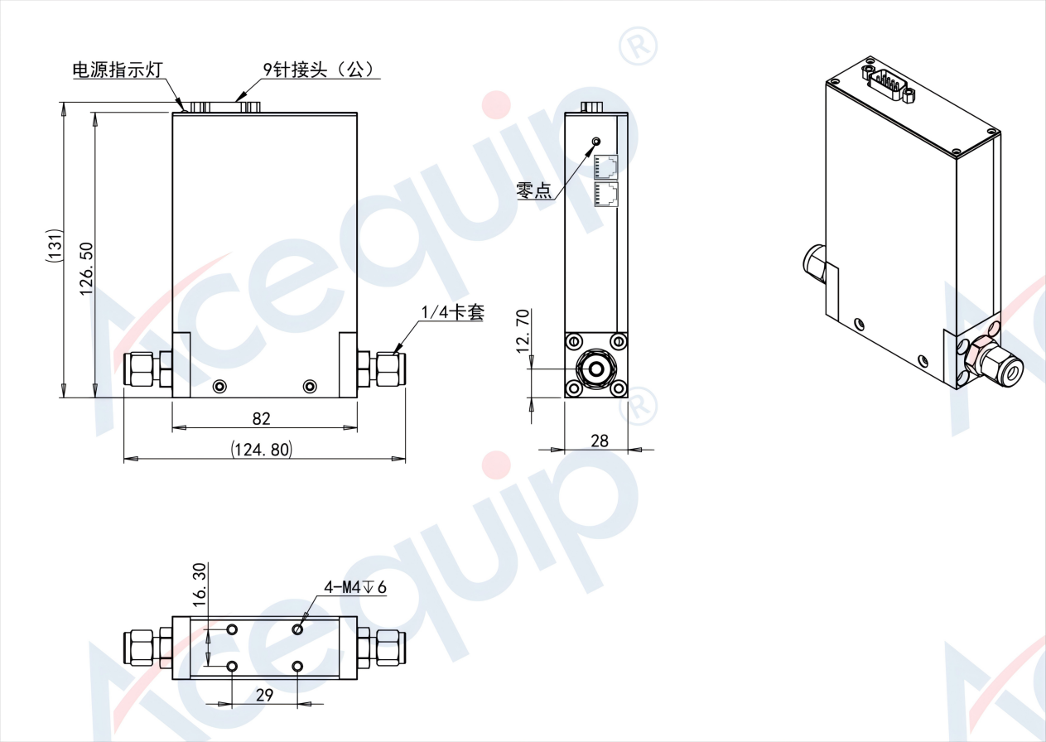

Acequip Digital（RS-485）Mass Flow Controller

A2-FCRRNCS-E4V/A2-FCRRVCS-E4V/A2-FMRRNS-E4V/A2-FMRRVS-E4V(1/4”M.VCR)

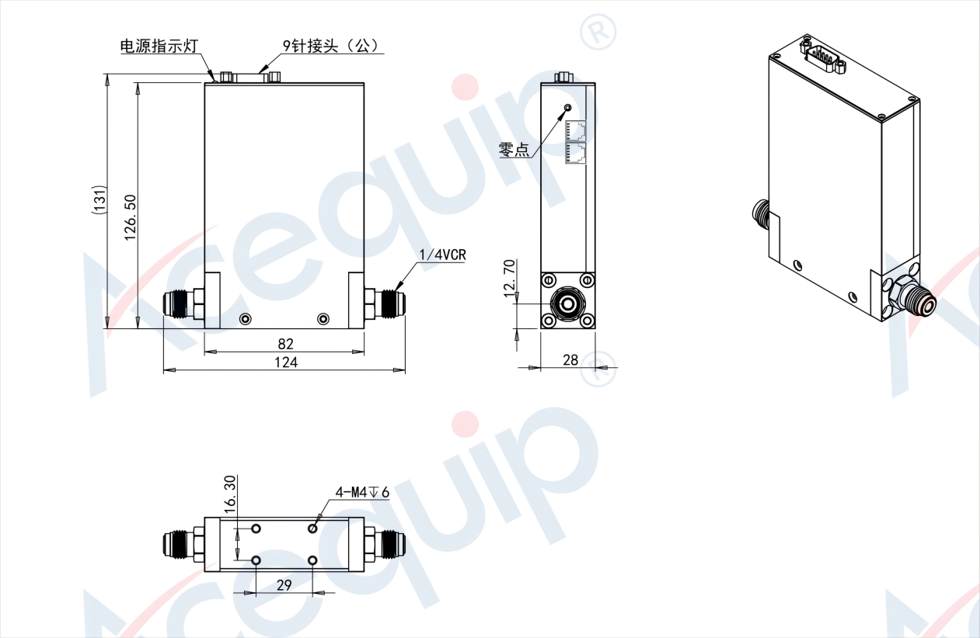

**Part Number Identification**

Acequip Digital（RS-485）Mass Flow Controller

A2-FCRRNCS/A2-FCRRVCS/A2-FMRRNS/A2-FMRRVS

