Acequip LCD Digital（RS-485）MFC/MFM

A2-FCRRMCS/A2-FCRRWCS/A2-FMRRMS/A2-FMRRWS

**Product Description**  
This advanced digital Mass Flow Controller (MFC) with integrated display offers high-performance flow measurement and control, ideal for precise and reliable flow management in demanding applications. Featuring an intuitive display interface, users can easily monitor, read, and adjust the flow settings. The controller is designed with an RS-485 communication interface, providing flexible integration into a wide range of industrial processes.

The compact design, combined with its highly accurate measurement capabilities, makes this MFC suitable for applications in industries such as semiconductor, biotechnology, chemicals, and cleanroom environments. The robust construction ensures reliable performance, even in the most challenging environments.

**Key Features:**

**Wide Flow Range:** The MFC supports a broad flow range from 2 sccm (milliliters per minute) to 50 slpm (liters per minute), offering precise control for a variety of gases, making it suitable for a wide range of flow applications.

**Power Supply Flexibility:** Available in two power supply configurations: dual power supply (±15VDC) or wide voltage input (+12VDC to +32VDC). This ensures seamless compatibility with various system setups and requirements.

**Advanced Communication Interface:** RS-485 digital communication interface with support for both ASCII and Modbus RTU protocols. This provides ease of integration into automated systems, enabling remote control and monitoring, which is crucial for industrial and research applications.

**Analog I/O Signals:** Equipped with 0 to 5 VDC analog input and output signals, enabling smooth integration with other devices and ensuring flexible control and monitoring of gas flow.

**Leak Rate:** Extremely low leak rate of Max 1x10^-9 Pa·m³/sec (He), which ensures high operational reliability and minimizes system contamination risks, particularly in sensitive applications.

**Real-Time Display:** The top-mounted digital display allows for real-time monitoring and adjustment of flow rates, improving usability and enabling users to quickly make changes when needed. This feature ensures ease of operation in both laboratory and industrial settings.

**Configurable Options:**

**Multi-Gas / Multi-Range Capability:** Configurable to support multiple gases and multiple flow ranges, providing flexibility for diverse applications across different industries.

**Sealing Options:** Available in both metal seal and all-metal seal configurations, offering options that cater to specific performance needs—whether it's for high corrosion resistance or ultra-high purity requirements.

**MFC/MFM Model Support:** Both Mass Flow Controller (MFC) and Mass Flow Meter (MFM) models are available, providing solutions for both precise flow control and accurate flow measurement, depending on application requirements.

**Specifications**

|  |  |
| --- | --- |
| Model | A2 |
| Full Scale Range(N2 eqv) | 2 SCCM |
| Response Time | ≤ 0.8 sec |
| Accuracy | ≥25% F.S. ：≤±1% S.P. |
| ＜25% F.S. ：≤± 0.25% F.S. |
| Linearity | ≤ ±0.5% of Full Scale |
| Repeatability | ±0.1% of Full Scale |
| Operating Differential Pressure | 2 SCCM – 10 SCCM：0.05 - 0.28 MPa |
| 6 SLM – 50 SLM：0.1 – 0.28 MPa |
| Leak Integrity | Viton Seal: Max 1x10-9Pa.m3/sec (He) |
| Metal/All Metal Seal: Max 1x10-11Pa.m3/sec (He) |
| Control Range | Single Gas： 2-100% of Full Scale |
| Multi Gas Multi Range：5-100% of Full Scale |
| Max operating Pressure | 0.48 MPa |
| Proof Pressure | 1 MPa |
| Operation Temperature | 5-45 Deg C |

|  |  |  |
| --- | --- | --- |
| Control Valve | Normally closed/Normally Open Solenoid Valve | |
| Fitting | 1/4"VCR or 1/4" Swagelok Compatible | |
| Seal | Viton Seal/Metal Seal/All Metal Seal | |
| Orientation | Free | |
| Wetted Material | Viton Seal：SUS316L, Viton, PTFE, Electromagnetic stainless steel | |
| Metal Seal：SUS316L, Ni, PTFE, Electromagnetic stainless steel | |
| All Metal Seal：SUS316L, Ni, Electromagnetic stainless steel | |
| Surface Finish | Viton Seal | ≤5RA |
| Metal Seal | TC，≤5RA |
| Weight | appr. 0.8 KG | |

**Mechanical**

**Electrical**

|  |  |  |
| --- | --- | --- |
| Analog Input Voltage | DC 0-5V | |
| Analog Output Voltage | DC 0-5V | |
| Power Supply | ±15VDC | +15VDC ±2% 25mA |
| -15VDC ±2% 180mA |
| +12VDC-+32VDC | +12VDC 500mA - +32VDC 180mA |
| Power Consumption | ±15VDC | 3.1W |
| +12VDC- +32VDC | 6W |
| Analog Connector | 9Pin D-sub Male | |
| RS-485 Connector | 6-Pin RJ-11 * 2 | |

**Dimensions**

Acequip LCD Digital（RS-485）MFC/MFM

A2-FCRRMCS-E4S/A2-FCRRWCS-E4S/A2-FMRRMS-E4S/A2-FMRRWS-E4S (1/4”LOK)

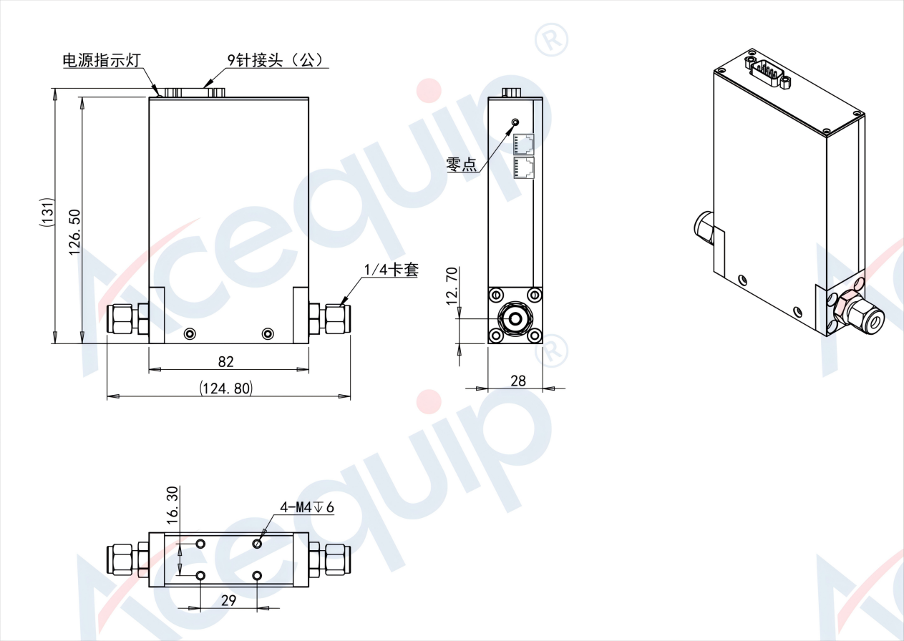

Acequip LCD Digital（RS-485）MFC/MFM

A2-FCRRMCS-E4V/A2-FCRRWCS-E4V/A2-FMRRMS-E4V/A2-FMRRWS-E4V(1/4”M.VCR)

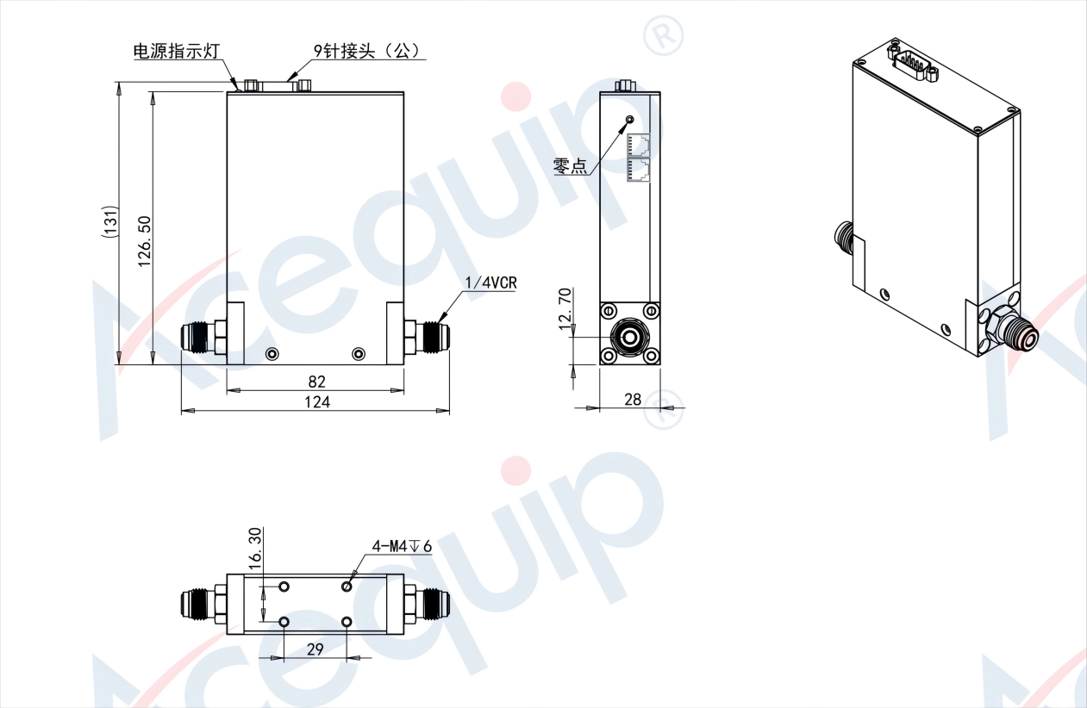

Acequip LCD Digital（RS-485）MFC/MFM

A2-FCMRMCS-IGW/A2-FCMRWCS-IGW/A2-FMMRMS-IGW/A2-FMMRWS-IGW (IGS 1.125"W-SEAL)

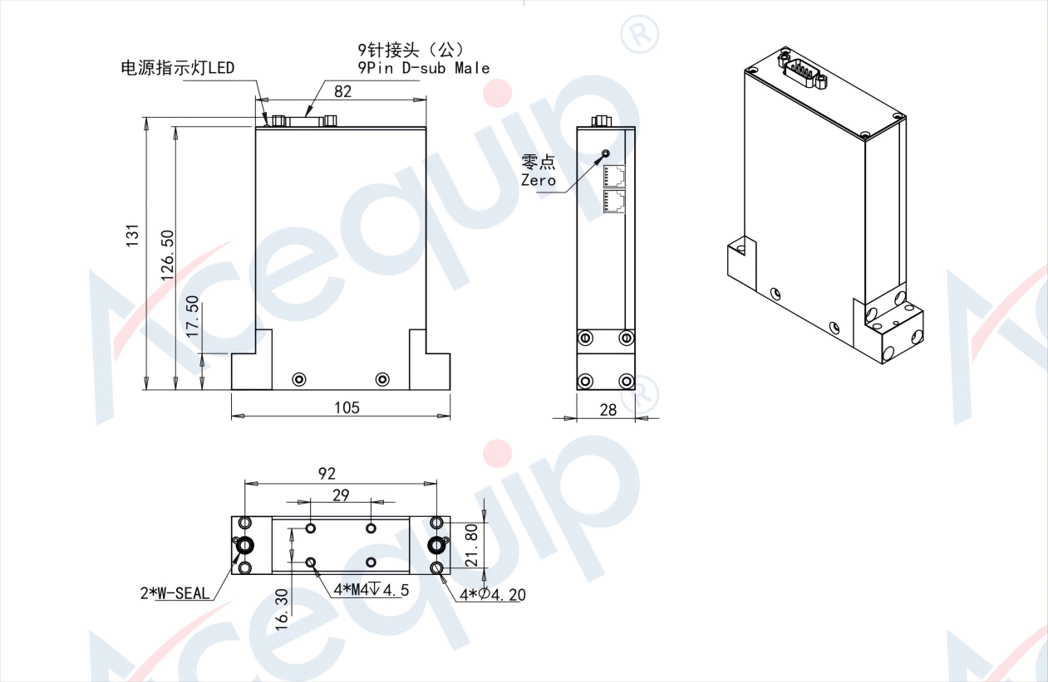

**Part Number Identification**

Acequip LCD Digital（RS-485）MFC/MFM

A2-FCRRMCS/A2-FCRRWCS/A2-FMRRMS/A2-FMRRWS

