Acequip Micro Flow（2SCCM）MFC/MFM

A2-FCRRNCS/A2-FCRRVCS/A2-FMRRNS/A2-FMRRVS

**Product Description**

This advanced micro-flow mass flow controller is designed for high-performance applications with a minimum full-scale range of 2 SCCM (N2 equivalent), delivering precise and stable control at the lowest full-scale flow rate of 1%. It is particularly well-suited for low-range applications, such as analytical instruments and other precise measurement tools.

**Key Features:**

* **Minimum Full-Scale Flow Rate:** 2 sccm (standard cubic centimeters per minute).
* **Dual Power Supply Options:** Compatible with dual power supply (±15VDC) or wide voltage range (+12~+32VDC).
* **RS-485 Digital Communication Interface:** Supports both ASCII and Modbus RTU communication protocols.
* **Analog Input/Output Signal:** 0～5VDC.
* **Leak Rate:**

Rubber Seal: Maximum 1x10^-9 Pa·m³/sec (He).

Metal Seal: Maximum 1x10^-11 Pa·m³/sec (He).

**Configurable Options：**

* **Multi-Gas/Multi-Range Functionality:** Configurable for multiple gases and flow ranges.
* **Seal Options:** Available in metal seal or full metal seal models.
* **Model Customization:** Supports ordering in both MFC (Mass Flow Controller) and MFM (Mass Flow Meter) configurations.

**Specifications**

|  |  |
| --- | --- |
| Model | A2 |
| Full Scale Range(N2 eqv) | 2 SCCM – 10 SCCM |
| Response Time | ≤ 0.8 sec |
| Accuracy | ≥25% F.S. ：≤±1% S.P. |
| ＜25% F.S. ：≤± 0.25% F.S. |
| Linearity | ≤±0.5% of Full Scale |
| Repeatability | ≤±0.1% of Full Scale |
| Operating Differential Pressure | 2 SCCM – 10 SCCM：0.05 - 0.28 MPa |
| Leak Integrity | Viton Seal：Max 1x10-9Pa.m3/sec (He) |
| Metal/All Metal Seal：Max 1x10-11Pa.m3/sec (He) |
| Control Range | Single Gas： 2-100% of Full Scale |
| Multi Gas Multi Range：5-100% of Full Scale |
| Max operating Pressure | 0.48 MPa |
| Proof Pressure | 1 MPa |
| Operation Temperature | 5-45 Deg C |

|  |  |
| --- | --- |
| Control Valve | Normally closed/Normally Open Solenoid Valve |
| Fitting | 1/4"VCR or 1/4" Swagelok Compatible |
| Seal | Viton Seal/Metal Seal/All Metal Seal |
| Orientation | Free |
| Wetted Material | Viton Seal：SUS316L, Viton, PTFE, Electromagnetic stainless steel |
| Metal Seal：SUS316L, Ni, PTFE, Electromagnetic stainless steel |
| All Metal Seal：SUS316L, Ni, Electromagnetic stainless steel |
| Surface Finish | ≤5RA |
| Weight | appr. 0.8 KG |

**Mechanical**

**Electrical**

|  |  |  |
| --- | --- | --- |
| Analog Input Voltage | DC 0-5V | |
| Analog Output Voltage | DC 0-5V | |
| Power Supply | ±15VDC | +15VDC ±2% 25mA |
| -15VDC ±2% 180mA |
| +12VDC-+32VDC | +12VDC 500mA - +32VDC 180mA |
| Power Consumption | ±15VDC | 3.1W |
| +12VDC- +32VDC | 6W |
| Analog Connector | 9Pin D-sub Male | |
| RS-485 Connector | 6-Pin RJ-11 * 2 | |

**Dimensions**

Acequip Micro Flow（2SCCM）MFC/MFM

A2-FCRRNCS/A2-FCRRVCS/A2-FMRRNS/A2-FMRRVS

(1/4”LOK)

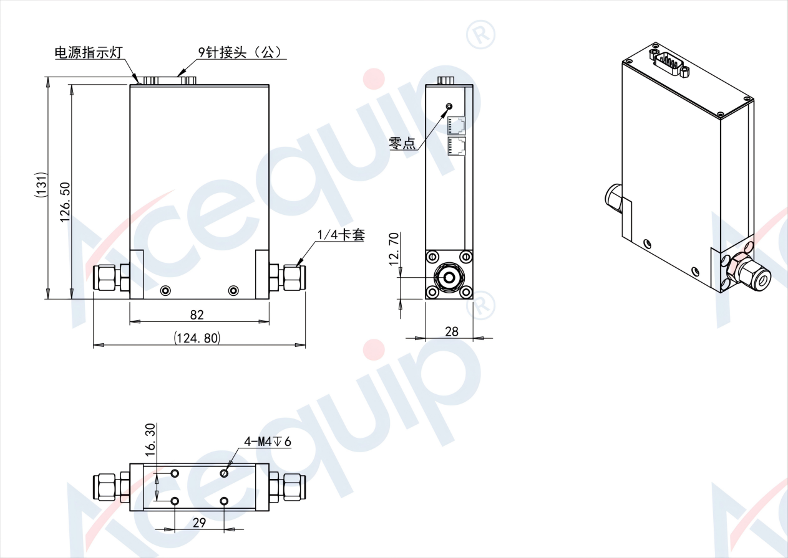

Acequip Micro Flow（2SCCM）MFC/MFM

A2-FCRRNCS-E4V/A2-FCRRVCS-E4V/A2-FMRRNS-E4V/A2-FMRRVS-E4V(1/4”M.VCR)

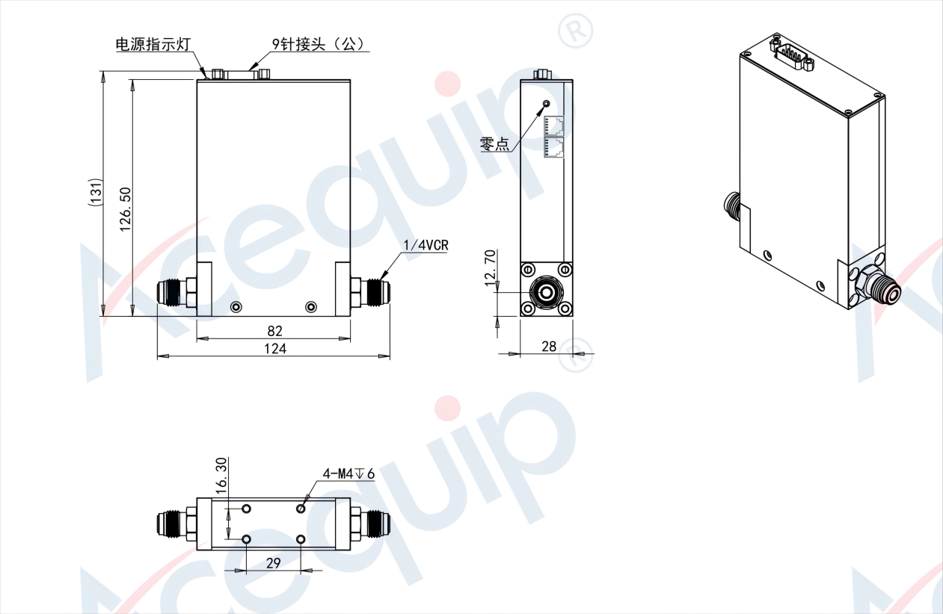

Acequip Micro Flow（2SCCM）MFC/MFM

A2-FCMRNCS-IGW/A2-FCMRVCS-IGW/A2-FMMRNS-IGW/A2-FMMRVS-IGW (IGS 1.125"W-SEAL)

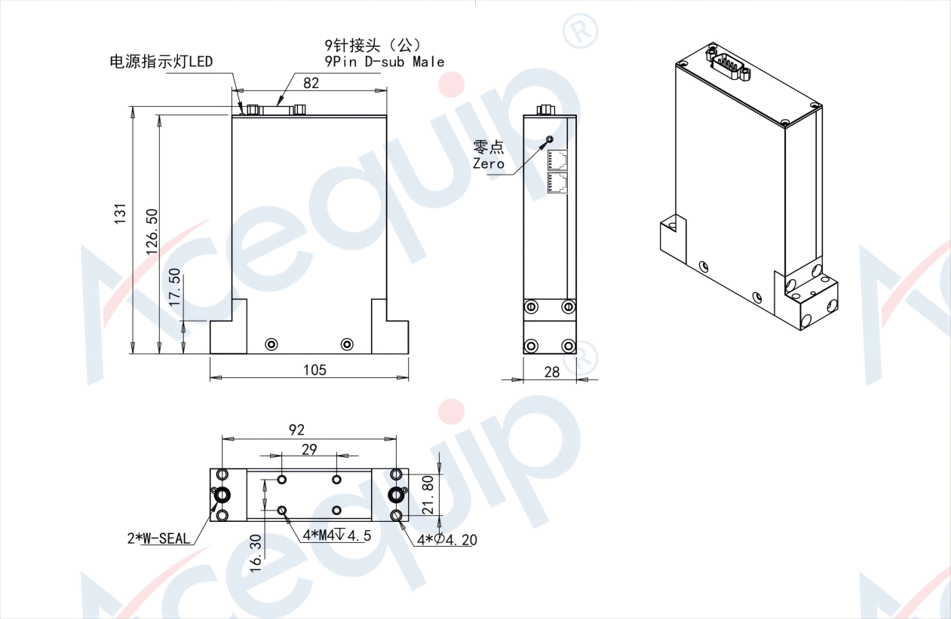

**Part Number Identification**

Acequip Micro Flow（2SCCM）MFC/MFM

A2-FCRRNCS/A2-FCRRVCS/A2-FMRRNS/A2-FMRRVS

