B2 Digital (50-150SLM) MFC/MFM B2-FCRANCV/B2-FCRAVCV/B2-FCRRNCS/B2-FCRRVCS

**Product Description**

The Acequip B2 mid-range mass flow controller is a high-performance device designed for precise and stable gas flow regulation within the full scale range of 50 to 150 SLM (standard liters per minute) . The adjustable flow range spans from 2% to 100% of the full-scale flow, ensuring accurate control at both low and high flow rates. With exceptional stability and high-accuracy control, this product is ideal for demanding applications such as semiconductor manufacturing, precision instrumentation, and laboratory research.

Features:

* ·Flow Range: Suitable for a wide flow range from 50 SLM to 150 SLM, meeting the needs of various industrial applications
* ·Power Supply Options: Two types of power inputs are supported: dual power supply (±15VDC) or wide voltage input (+12V ~ +32VDC)
* ·Digital Communication Interface: Equipped with RS-485 communication interface, compatible with both ASCII and Modbus RTU protocols for easy integration with automation systems
* ·Analog Signal I/O: Supports 0-5VDC voltage or 4-20mA current signal input/output
* ·Sealing Performance: Rubber seal leakage rate up to 1×10⁻⁹ Pa.m³/sec (He); Metal seal leakage rate up to 1×10⁻¹¹ Pa.m³/sec (He)

Configurable Options:

* Available in metal seal and full-metal seal models to accommodate different gas flow control requirements
* MFC (Mass Flow Controller) and MFM (Mass Flow Meter) models are available for selection, catering to various precision measurement needs

**Specifications**

|  |  |
| --- | --- |
| Model | B2 |
| Full Scale Range(N2 eqv) | 50 SLM– 150 SLM |
| Response Time | ≤ 1 秒 |
| Accuracy | ≤ ±1% of Full Scale |
| Linearity | ≤ ±1% of Full Scale |
| Repeatability | ≤ ±0.2% of Full Scale |
| Operating Differential Pressure | 0.15Mpa – 0.28Mpa |
| Leak Integrity | Viton Seal: Max 1x10-9Pa.m3/sec (He) |
| Metal/All Metal Seal: Max 1x10-11Pa.m3/sec (He) |
| Control Range | 2-100% of Full Scale |
| Max operating Pressure | 0.48 MPa |
| Proof Pressure | 1 MPa |
| Operation Temperature | 5-45 Deg C |

|  |  |  |
| --- | --- | --- |
| Control Valve | Normally closed/Normally Open Solenoid Valve | |
| Fitting | 3/8"VCR or 1/2"Swagelok Compatible | |
| Seal | Viton Seal/Metal Seal/All Metal Seal | |
| Orientation | Free | |
| Wetted Material | Viton Seal：SUS316L, Viton, PTFE, Electromagnetic stainless steel | |
| Metal Seal：SUS316L, Ni, PTFE, Electromagnetic stainless steel | |
| All Metal Seal：SUS316L, Ni, Electromagnetic stainless steel | |
| Surface Finish | Viton Seal | ≤5RA |
| Metal Seal | TC，≤5RA |
| Weight | appr. 2 KG | |

**Mechanical**

Electrical

|  |  |  |
| --- | --- | --- |
| Analog Input Voltage | DC 0-5V / 4-20mA | |
| Analog Output Voltage | DC 0-5V / 4-20mA | |
| Power Supply | ±15VDC | +15VDC ±2% 25mA |
| -15VDC ±2% 180mA |
| +12VDC-+32VDC | +12VDC 500mA - +32VDC 180mA |
| Power Consumption | ±15VDC | 3.1W |
| +12VDC- +32VDC | 6W |
| Analog Connector | 9Pin D-sub Male | |
| RS-485 Connector | 6-Pin RJ-11 * 2 | |

Dimensions

B2 Digital (50-150SLM) MFC/MFM

B2-FCRANCV-E6S/B2-FCRAVCV-E6S/B2-FCRRNCS-E6S/B2-FCRRVCS-E6S...

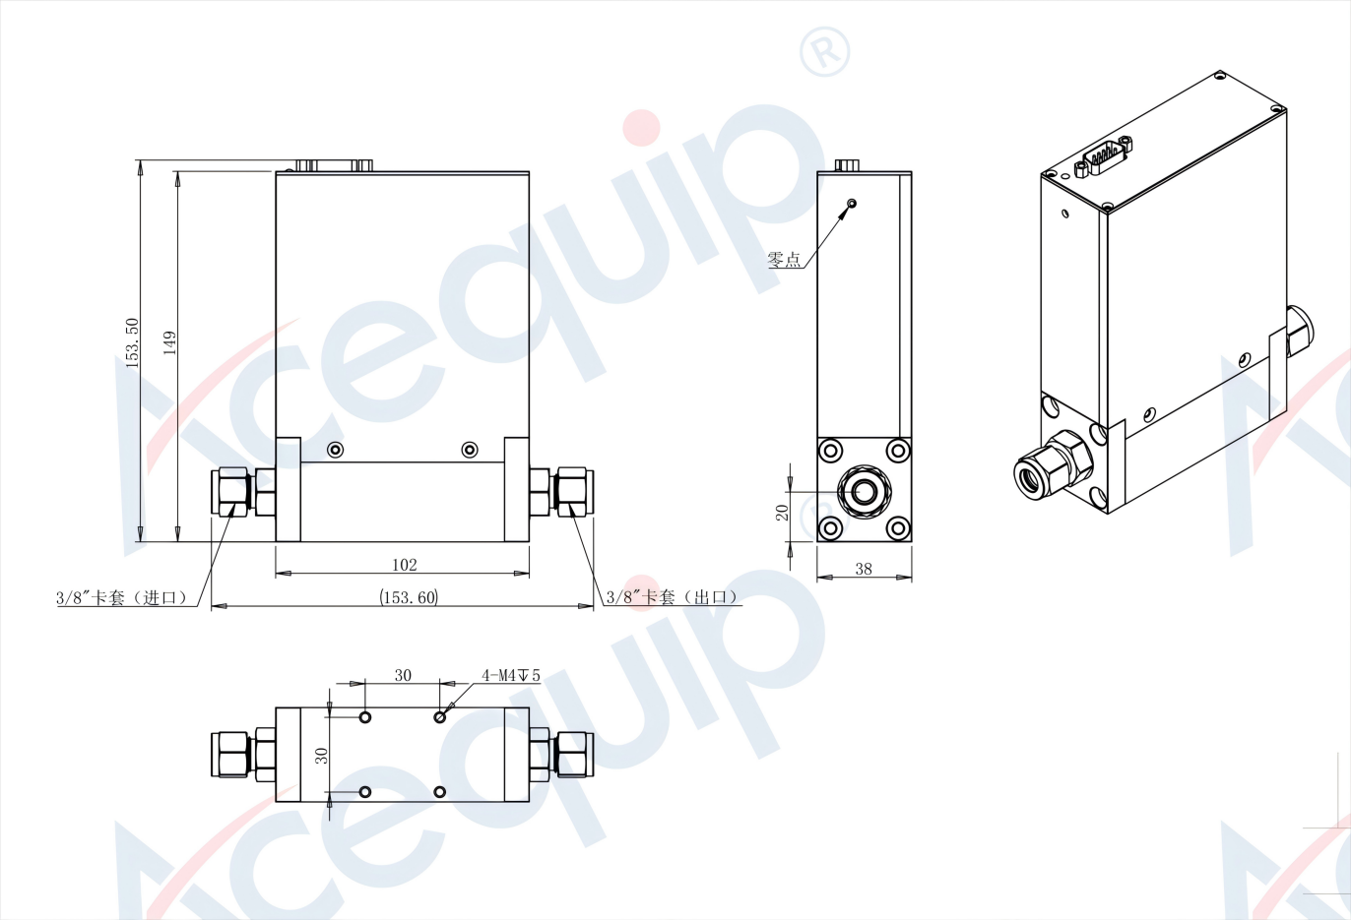

**Part Number Identification（Analog）**

B2 Digital (50-150SLM) MFC/MFM

B2-FCRANCV/B2-FCRAVCV/B2-FCRAVCI/B2-FCRAVV...

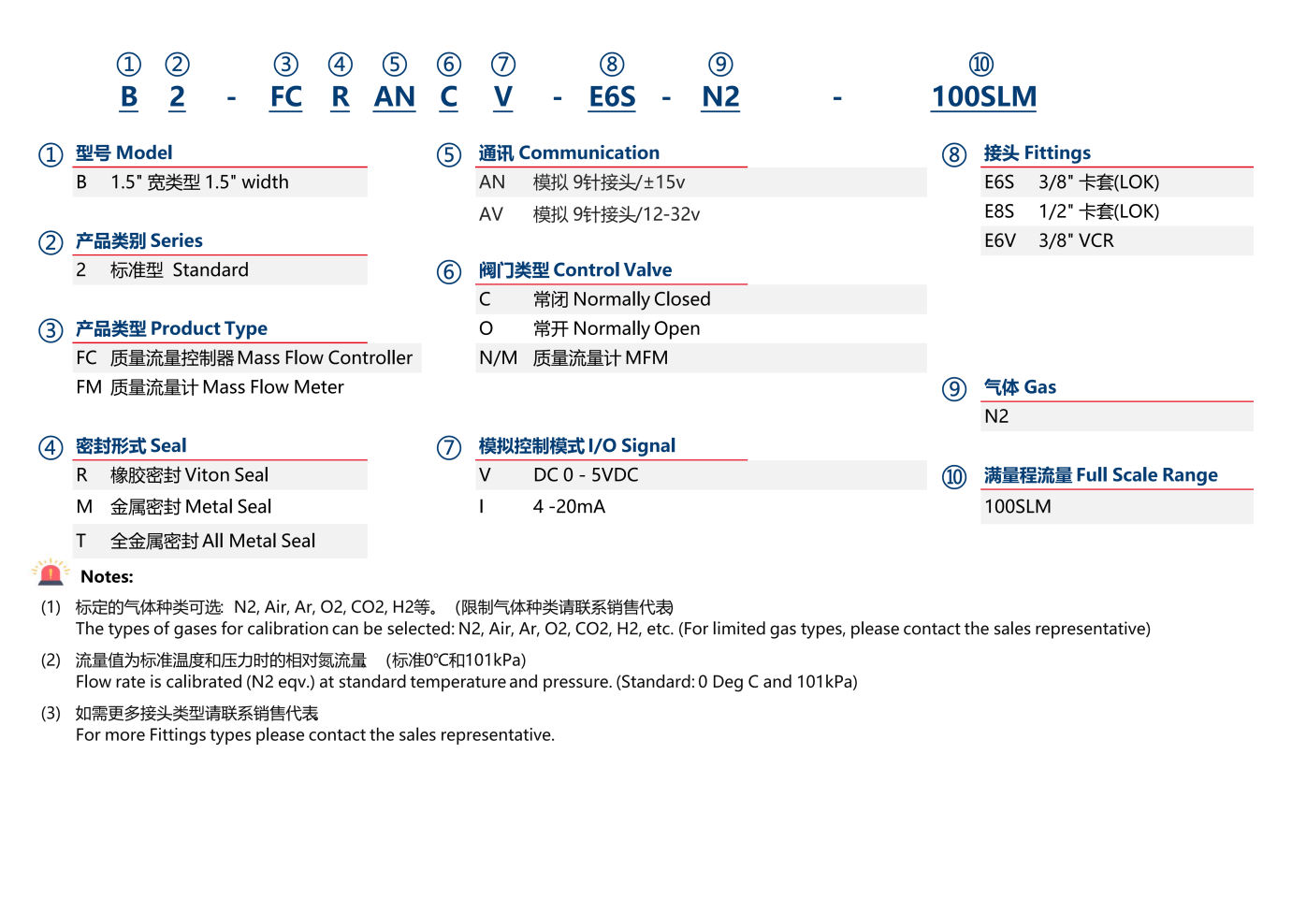

**Part Number Identification（Digital）**

B2 Digital (50-150SLM) MFC/MFM B2-FCRRNCS/B2-FCRRVCS/B2-FCRRVS...

