Acequip Ex-proof (2SCCM-50SLM) MFC/MFM

F1-FCRAVCV/F1-FCRRVCS/F1-FCMRVCS

产品描述

This Explosion-Proof Mass Flow Controller is engineered to provide both intrinsic safety and high-precision gas flow control in explosive and hazardous environments. Certified with EX explosion-proof and IP65 ingress protection, this device ensures reliable, accurate flow regulation in even the most demanding industrial applications.

* **Wide Flow Range:** Flow range from 2 sccm to 50 slm, offering precise control for a wide range of gases in explosive environments.
* **Explosion-Proof Certification:** Ex ib IIC T4 Gb certification ensures safe operation in environments with explosive gases and vapors, fully compliant with international safety standards.
* **Precision Gas Control:** High-accuracy flow measurement and control to maintain consistent and optimal performance in critical processes.
* **IP65 Protection:** IP65 rating ensures complete protection against dust and water ingress, making it ideal for harsh industrial environments, including outdoor and washdown areas.
* **Communication Protocols:** Supports ASCII and Modbus RTU protocols for seamless integration into existing automation systems, ensuring real-time monitoring and control.
* **Low Leak Rate:** Choose between rubber seals (max leak rate: 1x10^-9 Pa·m³/sec (He)) or metal seals (max leak rate: 1x10^-11 Pa·m³/sec (He)) for minimal leakage and enhanced operational safety.

**Specifications**

|  |  |
| --- | --- |
| Model | F1 |
| Full Scale Range(N2 eqv) | 2 SCCM – 50 SLM |
| Response Time | ≤ 0.8 sec |
| Accuracy | ≥25% F.S. ：≤±1% S.P. |
| ＜25% F.S. ：≤± 0.25% F.S. |
| Linearity | ≤±0.5% of Full Scale（30SLM以上≤1%） |
| Repeatability | ≤±0.1% of Full Scale |
| Operating Differential Pressure | 2 SCCM – 5 SLM：0.05 - 0.28 MPa |
| 6 SLM – 50 SLM：0.1 – 0.28 MPa |
| Leak Integrity | Viton Seal：Max 1x10-9Pa.m3/sec (He) |
| Metal/All Metal Seal：Max 1x10-11Pa.m3/sec (He) |
| Control Range | Single Gas： 2-100% of Full Scale |
| Multi Gas Multi Range：5-100% of Full Scale |
| Max operating Pressure | 0.48 MPa |
| Proof Pressure | 1 MPa |
| Operation Temperature | 5-45 Deg C |

|  |  |
| --- | --- |
| Control Valve | Normally closed/Normally Open Solenoid Valve |
| Fitting | 1/4"VCR or 1/4" Swagelok Compatible |
| Seal | Viton Seal/Metal Seal/All Metal Seal |
| Orientation | Free |
| Wetted Material | Viton Seal：SUS316L, Viton, PTFE, Electromagnetic stainless steel |
| Metal Seal：SUS316L, Ni, PTFE, Electromagnetic stainless steel |
| All Metal Seal：SUS316L, Ni, Electromagnetic stainless steel |
| Surface Finish | ≤5RA |
| Weight | appr. 0.8 KG |

**Mechanical**

Electrical

|  |  |  |
| --- | --- | --- |
| Analog Input Voltage | DC 0-5V / 4-20mA | |
| Analog Output Voltage | DC 0-5V / 4-20mA | |
| Power Supply | +12VDC 500mA ～+24VDC 250mA | |
| Power Consumption | +12VDC- +24VDC | 6W |
| Analog Connector |  | |
| RS-485 Connector | RS-485 | |

Dimensions

Acequip Ex-proof (2SCCM-50SLM) MFC/MFM

F1-FCRAVCV-E4V/F1-FCRRVCS-E4V/F1-FCMRVCS-E4V...（1/4”M.VCR）

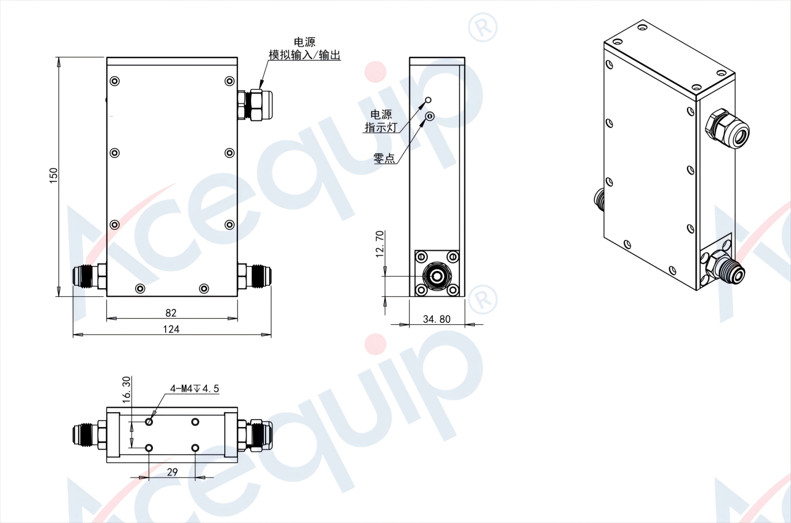

**Part Number Identification （Analog Model）**

Acequip Ex-proof (2SCCM-50SLM) MFC/MFM

F1-FCRAVCV/F1-FMAVCI/F1-FCRAVV...

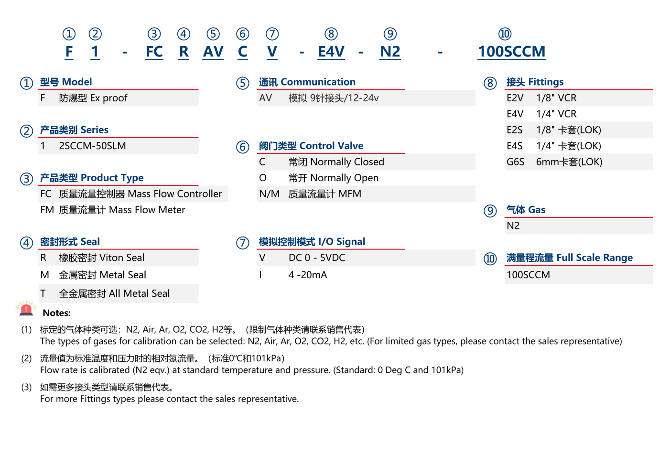

**Part Number Identification （Digital Model）**

Acequip Ex-proof (2SCCM-50SLM) MFC/MFM

F1-FCRRVCS/F1-FMRVCS/F1-FCMRVS...

