Acequip High-Temperature (80°C-120°C) Mass Flow Controller A2-FCTRNCH/A2-FCTRVCH

**Product Description**

The Acequip High-Temperature Digital Mass Flow Controller is engineered to meet the demanding requirements of high-temperature gas flow control applications, with an operating temperature range from 80°C to 120°C. Designed with high-purity metal seals and cutting-edge technology, this controller ensures minimal contamination, making it ideal for integration with vaporizers in critical industrial applications such as semiconductor manufacturing, chemical vapor deposition (CVD), and plasma etching. The precise and stable control of vaporized gases ensures uniformity in deposition processes, significantly enhancing process reliability and efficiency.

**Key Features:**

* **Operating Temperature Range: 80°C to 120°C**
* **High-purity metal seals:** Provides superior leak-proof sealing to prevent external contamination, ensuring high-quality gas flow control.
* **RS-485 Digital Communication Interface:** Compatible with both ASCII and Modbus RTU protocols for seamless integration with automated control systems.
* **Leak Rate:** Maximum 1x10^-11 Pa·m³/sec (He), ensuring excellent performance in ultra-sensitive environments.
* **Configurable Options:**
* **Low differential pressure** operation for enhanced precision in critical applications.
* **Surface passivation treatment** for improved durability and resistance to harsh industrial environments.

Specifications

|  |  |
| --- | --- |
| Model | A2 |
| Full Scale Range(N2 eqv) | 2 SCCM – 5 SLM |
| Response Time | ≤ 3 sec |
| Accuracy | ≥25% F.S. ：≤±1% S.P. |
| ＜25% F.S. ：≤± 0.25% F.S. |
| Linearity | ≤±0.5% of Full Scale |
| Repeatability | ≤±0.2% of Full Scale |
| Operating Differential Pressure | 0.05 - 0.28 MPa |
| Leak Integrity | Max 1x10-11Pa.m3/sec (He) |
| Control Range | Single Gas： 2-100% of Full Scale |
| Max operating Pressure | 0.48 MPa |
| Proof Pressure | 1 MPa |
| Operation Temperature | 80-120 Deg C |

|  |  |
| --- | --- |
| Control Valve | Normally closed/Normally Open Solenoid Valve |
| Fitting | 1/4"VCR or 1/4" Swagelok Compatible |
| Seal | All Metal Seal |
| Orientation | Free |
| Wetted Material | All Metal Seal：SUS316L, Ni, Electromagnetic stainless steel |
| Surface Finish | TC，≤5RA |
| Weight | appr. 1.2 KG |

**Mechanical**

|  |  |  |
| --- | --- | --- |
| Analog Input Voltage | DC 0-5V | |
| Analog Output Voltage | DC 0-5V | |
| Power Supply | ±15VDC | +15VDC ±2% 25mA |
| -15VDC ±2% 180mA |
| +12VDC-+32VDC | +12VDC 500mA - +32VDC 180mA |
| Power Consumption | ±15VDC | 3.1W |
| +12VDC- +32VDC | 6W |
| Analog Connector | 9Pin D-sub Male | |
| RS-485 Connector | 6-Pin RJ-11 * 2 | |

**Mechanical**

Dimensions

Acequip High-Temperature (80°C-120°C) Mass Flow Controller A2-FCTRNCH-E4V/A2-FCTRVCH-E4V (Valve)

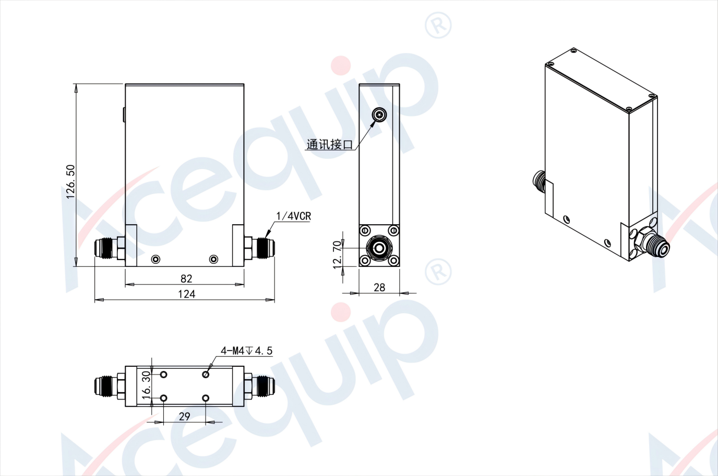

Acequip High-Temperature (80°C-120°C) Mass Flow Controller A2-FCTRNCH-E4V/A2-FCTRVCH-E4V (Control)

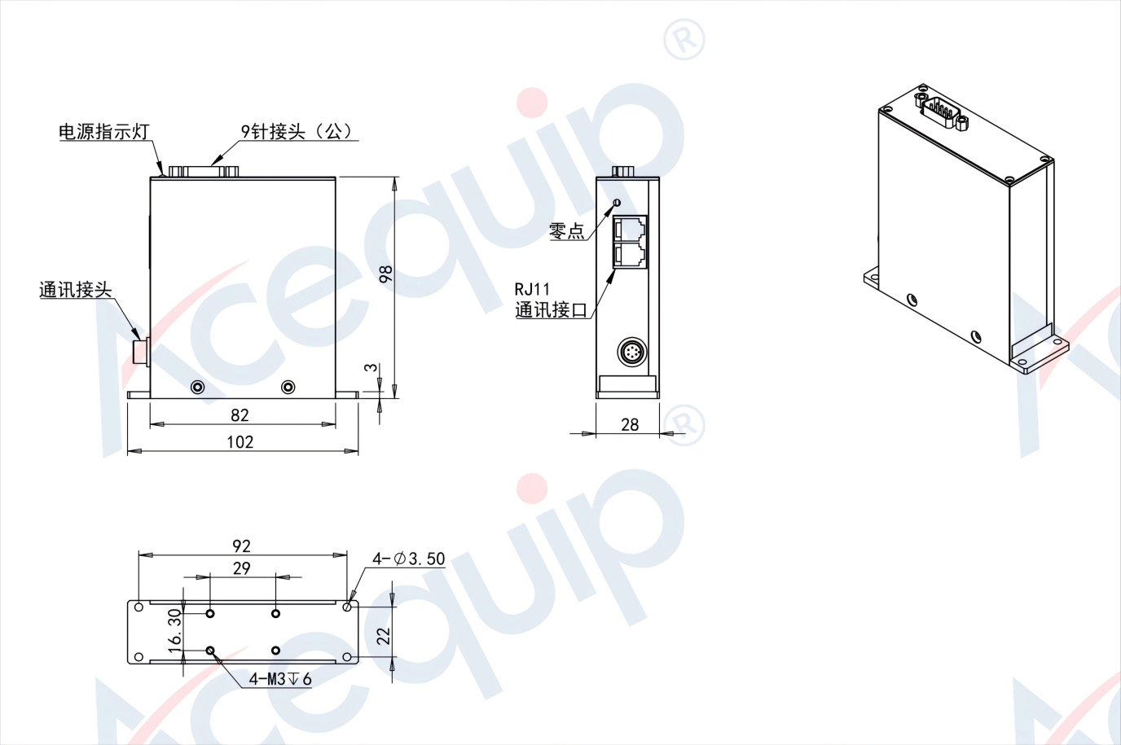

**Part Number Identification**

Acequip High-Temperature (80°C-120°C) Mass Flow Controller A2-FCTRNCH/A2-FCTRVCH

