Acequip Digital (EtherCAT) MFC/MFM A2-FCRECCS/A2-FCMECCS/A2-FCTECCS

**Product Description**

The **Acequip EtherCAT Mass Flow Controller** is a high-performance digital flow control solution designed for precise and reliable gas flow regulation in cutting-edge industrial applications. Compliant with **SEMI standards**, it utilizes a high-accuracy flow sensor to ensure an **accuracy range of ±1% S.P. (set point)**. **EtherCAT** communication enables ultra-fast, real-time control and data exchange, making it ideal for high-tech industries requiring high precision and high repeatability, such as **semiconductor manufacturing**, **laboratory automation**, and **advanced material research**.

**Key Features**

* **Flow Range:** From 2 SCCM (milliliters per minute) to 50 SLM (standard liters per minute), suitable for a wide range of applications.
* **Metal Sealing Option:** Provides superior leak-tight performance, with a leak rate of Max 1x10^-11 Pa·m³/sec (He), ensuring ultra-high purity and reliability.
* **EtherCAT Communication:** Ensures fast, deterministic communication for seamless integration with other devices in automated systems.
* **High Precision and Repeatability:** Achieves ±1% S.P. (set point) accuracy, ensuring consistent and repeatable performance for critical applications.
* **Connection Type Options:** Available with IGS connectors for enhanced compatibility and integration.

**Specifications**

|  |  |
| --- | --- |
| Model | A2 |
| Full Scale Range(N2 eqv) | 2 SCCM – 50 SLM |
| Response Time | ≤ 0.8 sec |
| Accuracy | ≥25% F.S. ：≤±1% S.P. |
| ＜25% F.S. ：≤± 0.25% F.S. |
| Linearity | ≤±0.5% of Full Scale（30SLM以上≤1%） |
| Repeatability | ≤±0.1% of Full Scale |
| Operating Differential Pressure | 2 SCCM – 5 SLM：0.05 - 0.28 MPa |
| 6 SLM – 50 SLM：0.1 – 0.28 MPa |
| Leak Integrity | Viton Seal：Max 1x10-9Pa.m3/sec (He) |
| Metal/All Metal Seal：Max 1x10-11Pa.m3/sec (He) |
| Control Range | Single Gas： 2-100% of Full Scale |
| Multi Gas Multi Range：5-100% of Full Scale |
| Max operating Pressure | 0.48 MPa |
| Proof Pressure | 1 MPa |
| Operation Temperature | 5-45 Deg C |

|  |  |
| --- | --- |
| Control Valve | Normally closed/Normally Open Solenoid Valve |
| Fitting | 1/4"VCR or 1/4" Swagelok Compatible |
| Seal | Viton Seal/Metal Seal/All Metal Seal |
| Orientation | Free |
| Wetted Material | Viton Seal：SUS316L, Viton, PTFE, Electromagnetic stainless steel |
| Metal Seal：SUS316L, Ni, PTFE, Electromagnetic stainless steel |
| All Metal Seal：SUS316L, Ni, Electromagnetic stainless steel |
| Surface Finish | ≤5RA |
| Weight | appr. 0.8 KG |

**Mechanical**

**Electrical**

|  |  |  |
| --- | --- | --- |
| Communication | EtherCAT | |
| Power Supply | +12VDC-+32VDC | +12VDC 500mA - +32VDC 180mA |
| Power Consumption | +12VDC- +32VDC | 6W |
| RS-485 Connector | M8 5Pin Male | |
| RJ45*2 | |

**Dimensions**

Acequip Digital EtherCAT Mass Flow Controller

A2-FCREWCS-E4V/A2-FCMEWCS-E4V/A2-FCTEWCS-E4V/A2-FCRECCS-E4V/A2-FCMECCS-E4V/A2-FCTECCS-E4V

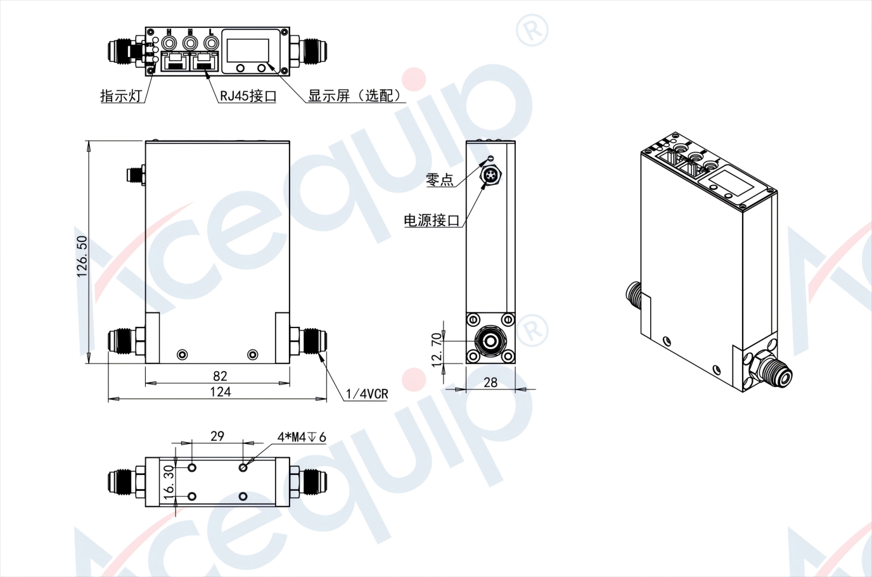

Acequip Digital EtherCAT Mass Flow Controller

A2-FCRECCS-IGW/A2-FCMECCS-IGW/A2-FCTECCS-IGW (IGS 1.125"W-SEAL)

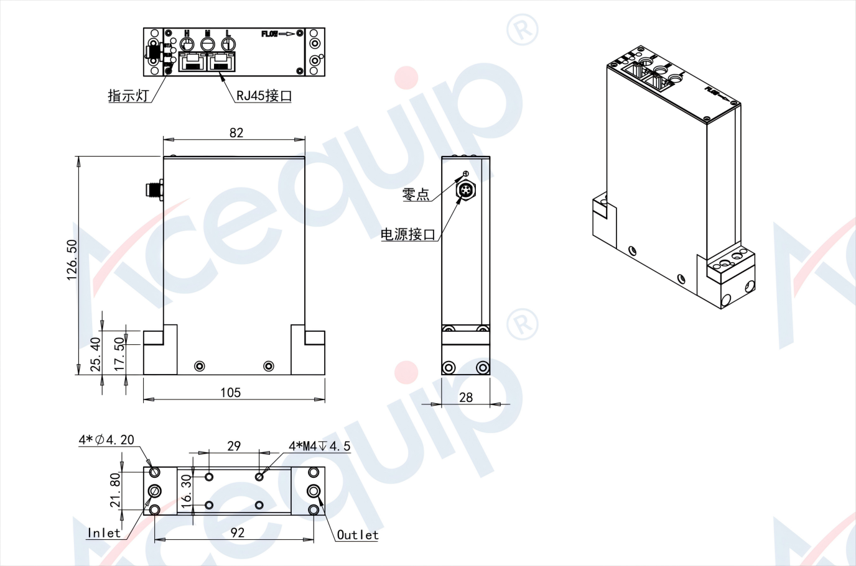

**Part Number Identification**

Acequip Digital EtherCAT Mass Flow Controller

A2-FCRECCS-E4V/A2-FCMECCS-E4V/A2-FCTECCS-E4V

