Acequip M1 Series Ultra-Compact (10SCCCM-5SLM) MFC M1-FCRRVCS

**Product Description**

The M1 Series ultra-compact mass flow controller from Acequip is an ideal solution for applications with limited space, such as analytical instruments and environmental monitoring systems. With customizable flow ranges from 10 SCCM to 5 SLM, it offers fast, stable response and minimal overshoot, ensuring precise control for demanding applications. Designed for high accuracy and cost-efficiency, it's perfect for those who need reliable performance without compromising on size or budget.

**Features：**

* Compact design, optimizing both cost efficiency and space utilization.
* Power supply: Wide input voltage range (+12V to +32V DC).
* RS-485 digital communication interface, compatible with both ASCII and Modbus RTU communication protocols.
* Leak rate: Maximum 1x10^-9 Pa·m³/sec (He).

**Specifications**

|  |  |
| --- | --- |
| Model | M1 |
| Full Scale Range(N2 eqv) | 10 SCCM – 5 SLM |
| Response Time | ≤ 0.8 sec |
| Accuracy | ≥25% F.S. ：≤±1% S.P. |
| ＜25% F.S. ：≤± 0.25% F.S. |
| Linearity | ≤ ±0.5% of Full Scale |
| Repeatability | ±0.1% of Full Scale |
| Operating Differential Pressure | 0.2 - 0.5 MPa |
| Leak Integrity | Max 1x10-9Pa.m3/sec (He) |
| Control Range | Single Gas： 2-100% of Full Scale |
| Max operating Pressure | 0.6 MPa |
| Proof Pressure | 1 MPa |
| Operation Temperature | 5-45 Deg C |

|  |  |
| --- | --- |
| Control Valve | Normally closed/Normally Open Solenoid Valve |
| Fitting | 1/8" straight thread, 1/8" tapered thread, or 1/8" compression fitting. |
| Seal | Viton Seal |
| Orientation | Free |
| Wetted Material | Viton Seal：SUS316L, Viton, PTFE, Electromagnetic stainless steel |
| Surface Finish | ≤5RA |
| Weight | appr. 0.28 KG |

**Mechanical**

|  |  |  |
| --- | --- | --- |
| Analog Input Voltage | DC 0-5V | |
| Analog Output Voltage | DC 0-5V | |
| Power Supply | +12VDC-+32VDC | +12VDC 500mA - +32VDC 180mA |
| Power Consumption | +12VDC- +32VDC | Max 6W |
| RS-485 Connector | RJ-45 | |

**Electrical**

**Dimensions**

Acequip M1 Series Ultra-Compact (10SCCCM-5SLM) MFC

M1-FCRRVCS-E2R

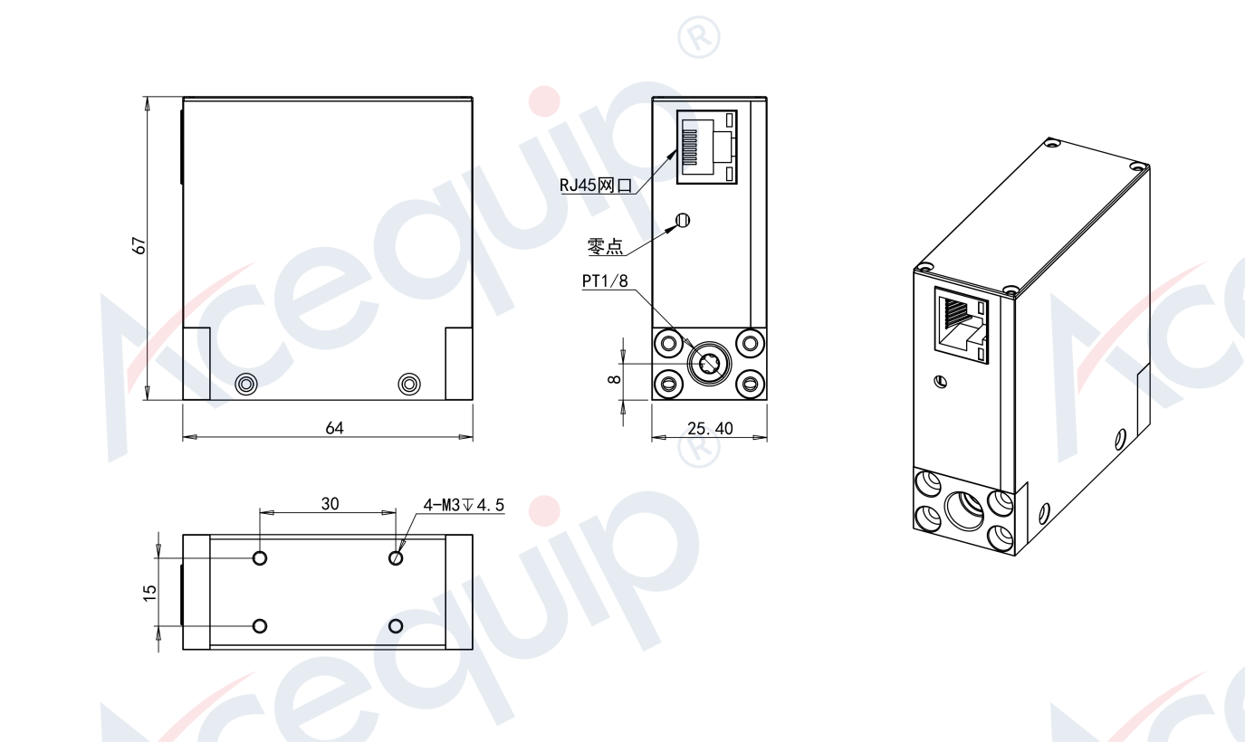

**Part Number Identification**

Acequip M1 Series Ultra-Compact (10SCCCM-5SLM) MFC

M1-FCRRVCS

