A2 High-prssure (10SCCM-30SLM) MFC

A2-FCPRNCS/A2-FCPRVCS/A2-FMPRNS/A2-FMPRVS

**Product Description**

This high-pressure gas mass flow controller is designed for demanding high-pressure applications, with a proof pressure of 10 MPa, ensuring reliability and safety under extreme conditions. Its fast response time and precise flow control make it ideal for high-pressure gas flow regulation, widely used in chemical engineering, semiconductor manufacturing, laboratory research, and other industries.

Features:

* Maximum proof pressure 10 MPa
* Fast response time for precise flow control
* Available with rubber or metal seals
* Suitable for various high-pressure gas flow control applications
* Reliable and durable, designed for harsh environments

**Specifications**

|  |  |
| --- | --- |
| Model | A2 |
| Full Scale Range(N2 eqv) | 10 SCCM – 30 SLM |
| Response Time | ≤ 1 sec |
| Accuracy | ≥25% F.S. ：≤±1% S.P. |
| ＜25% F.S. ：≤± 0.25% F.S. |
| Linearity | ≤ ±0.5% of Full Scale |
| Repeatability | ≤ ±0.1% of Full Scale |
| Operating Differential Pressure | 0.2 – 0.8 MPa |
| Leak Integrity | Viton Seal: Max 1x10-9Pa.m3/sec (He) |
| Metal/All Metal Seal: Max 1x10-11Pa.m3/sec (He) |
| Control Range | Single Gas： 2-100% of Full Scale |
| Multi Gas Multi Range：5-100% of Full Scale |
| Proof Pressure | 10 MPa |
| Operation Temperature | 5-45 Deg C |

|  |  |  |
| --- | --- | --- |
| Control Valve | Normally closed Solenoid Valve | |
| Fitting | 1/4"VCR or 1/4" Swagelok Compatible | |
| Seal | Viton Seal/Metal Seal/All Metal Seal | |
| Orientation | Free | |
| Wetted Material | Viton Seal：SUS316L, Viton, PTFE, Electromagnetic stainless steel | |
| Metal Seal：SUS316L, Ni, PTFE, Electromagnetic stainless steel | |
| All Metal Seal：SUS316L, Ni, Electromagnetic stainless steel | |
| Surface Finish | Viton Seal | ≤5RA |
| Metal Seal | TC，≤5RA |
| Weight | appr. 0.8 KG | |

**Mechanical**

**Electrical**

|  |  |  |
| --- | --- | --- |
| Analog Input Voltage | DC 0-5V | |
| Analog Output Voltage | DC 0-5V | |
| Power Supply | ±15VDC | +15VDC ±2% 25mA |
| -15VDC ±2% 180mA |
| +12VDC-+32VDC | +12VDC 500mA - +32VDC 180mA |
| Power Consumption | ±15VDC | 3.1W |
| +12VDC- +32VDC | 6W |
| Analog Connector | 9Pin D-sub Male | |
| RS-485 Connector | 6-Pin RJ-11 * 2 | |

**Dimensions**

A2 High-prssure (10SCCM-30SLM) MFC

A2-FCPRNCS-E4S/A2-FCPRVCS-E4S/A2-FMPRNS-E4S/A2-FMPRVS-E4S

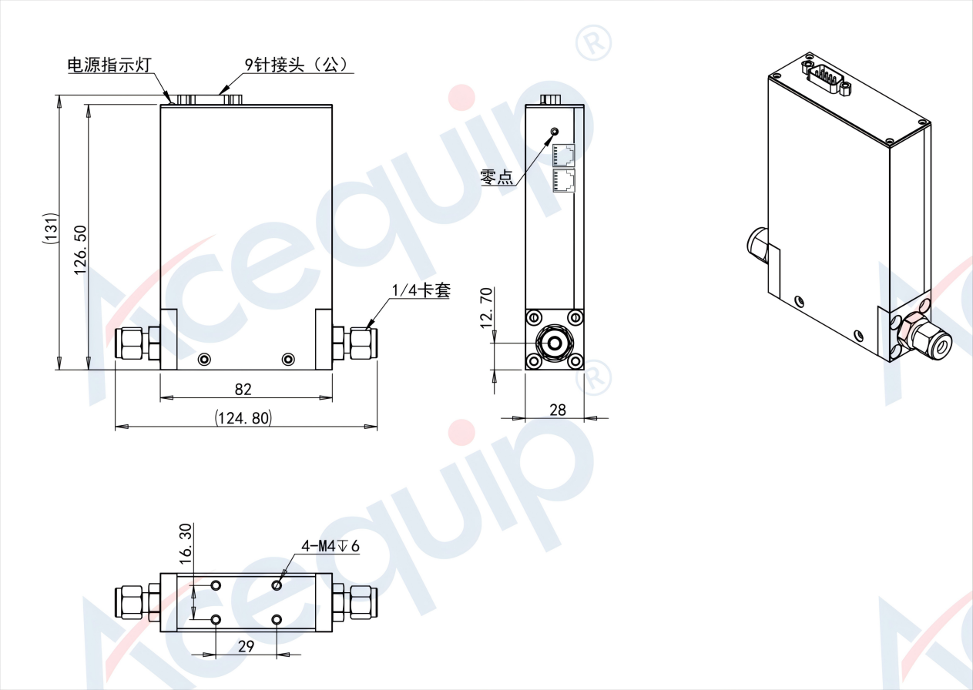

A2 High-prssure (10SCCM-30SLM) MFC

A2-FCPRNCS-E4V/A2-FCPRVCS-E4V/A2-FMPRNS-E4V/A2-FMPRVS-E4V

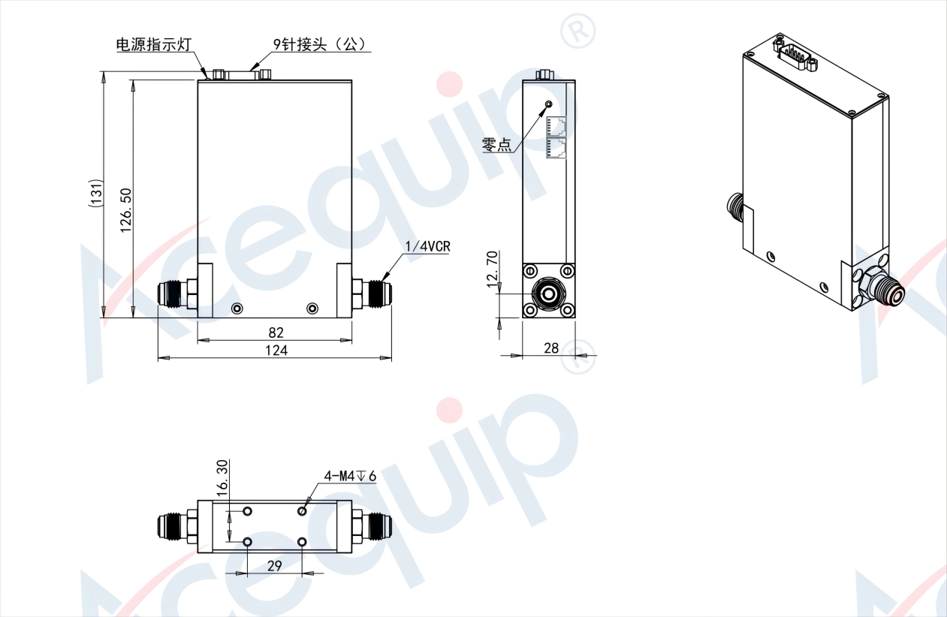

**Part Number Identification**

A2 High-prssure (10SCCM-30SLM) MFC

A2-FCPRNCS/A2-FCPRVCS/A2-FMPRNS/A2-FMPRVS

