D2 Digital (300-2000 SLM) MFC/MFM

D2-FCRANCV/D2-FCRAVCV/D2-FCRRNCS/D2-FCRRVCS

**Product Description**

The Acequip D2 Series digital mass flow controllers (MFCs) and mass flow meters (MFMs) deliver high-accuracy, fast response, and exceptional repeatability for high-flow gas applications. Designed for flow rates from 300 to 2000 SLM, the D2 Series ensures stable and reliable gas flow control in semiconductor manufacturing, large-area display production, biotechnology, plasma processing, and industrial gas distribution. With advanced digital control, flexible communication interfaces, and robust sealing performance, the D2 Series seamlessly integrates into automation and process control systems.

Features:

* ·Flow Range: Suitable for a wide flow range from 300 SLM to 2000 SLM, meeting the needs of various industrial applications
* ·Power Supply Options: Two types of power inputs are supported: dual power supply (±15VDC) or wide voltage input (+12V ~ +32VDC)
* ·Digital Communication Interface: Equipped with RS-485 communication interface, compatible with both ASCII and Modbus RTU protocols for easy integration with automation systems
* ·Analog Signal I/O: Supports 0-5VDC voltage or 4-20mA current signal input/output
* ·Sealing Performance: Rubber seal leakage rate up to 1×10⁻⁹ Pa.m³/sec (He);

Configurable Options:

* MFC (Mass Flow Controller) and MFM (Mass Flow Meter) models are available for selection, catering to various precision measurement needs

**Specifications**

|  |  |
| --- | --- |
| Model | D2 |
| Full Scale Range(N2 eqv) | 100 SLM– 300 SLM |
| Response Time | ≤ 3 sec |
| Accuracy | ≤± 2% F.S. |
| Linearity | ≤ ±1% of Full Scale |
| Repeatability | ≤ ±0.25% of Full Scale |
| Operating Differential Pressure | 0.25 - 0.7MPA |
| Leak Integrity | Viton Seal: Max 1x10-9Pa.m3/sec (He) |
| Control Range | 2-100% of Full Scale |
| Proof Pressure | 3 MPa |
| Operation Temperature | 5-45 Deg C |

|  |  |  |
| --- | --- | --- |
| Control Valve | Normally closed Solenoid Valve | |
| Fitting | 1/2"VCR, 3/4"Swagelok or 1"Swagelok Compatible | |
| Seal | Viton Seal | |
| Orientation | Free | |
| Wetted Material | Viton Seal：SUS316L, Viton, PTFE, Electromagnetic stainless steel | |
| Surface Finish | Viton Seal | ≤5RA |
| Weight | appr. 5 KG | |

**Mechanical**

Electrical

|  |  |  |
| --- | --- | --- |
| Analog Input Voltage | DC 0-5V / 4-20mA | |
| Analog Output Voltage | DC 0-5V / 4-20mA | |
| Power Supply | ±15VDC | +15VDC ±2% 25mA |
| -15VDC ±2% 180mA |
| +12VDC-+32VDC | +12VDC 500mA - +32VDC 180mA |
| Power Consumption | ±15VDC | 3.1W |
| +12VDC- +32VDC | 6W |
| Analog Connector | 9Pin D-sub Male | |
| RS-485 Connector | 6-Pin RJ-11 * 2 | |

Dimensions

D2 Analog (300-2000 SLM) MFC/MFM

D2-FCRANCV-E8V/D2-FCRAVCV-E8V

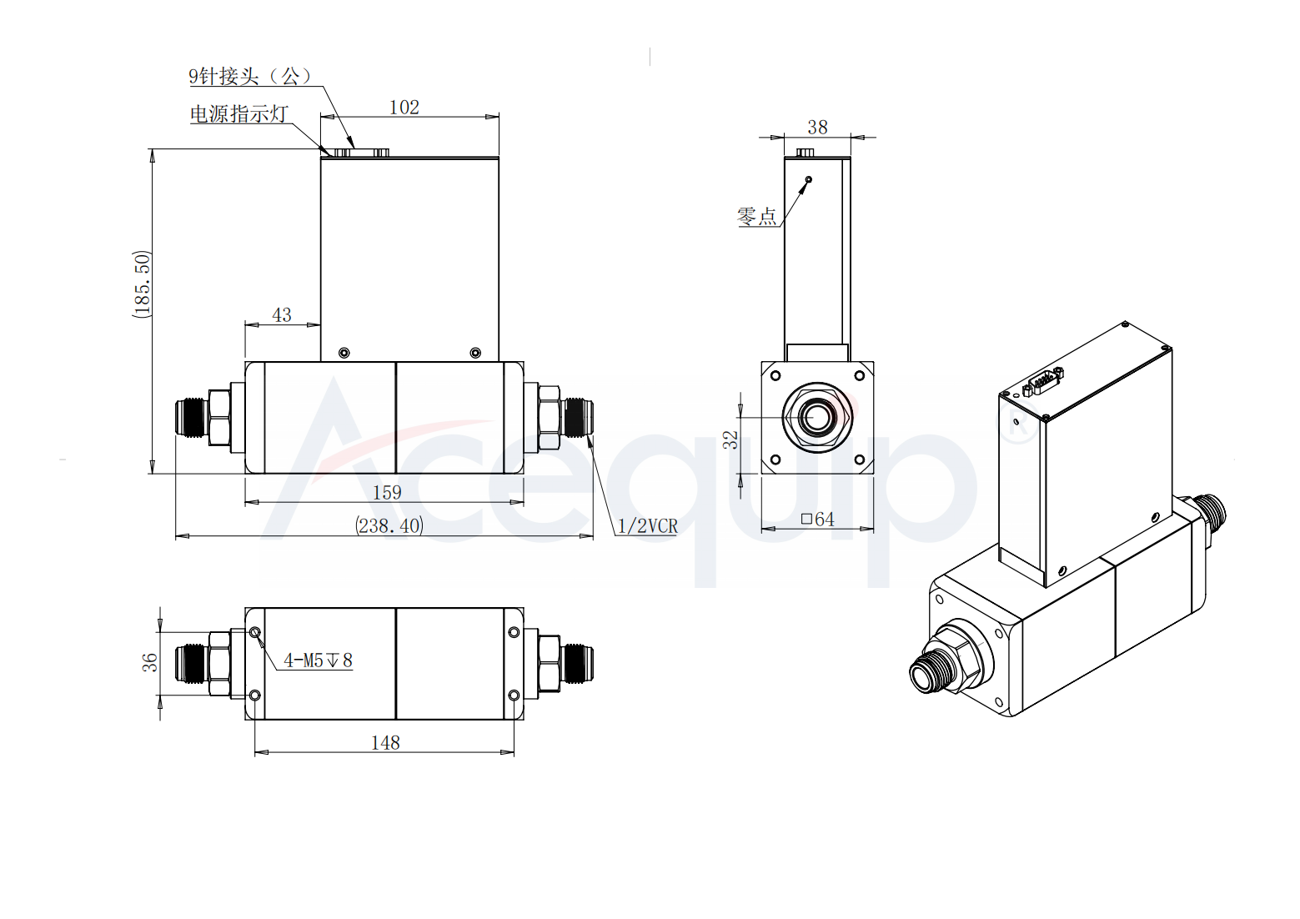

D2 Digital (300-2000 SLM) MFC/MFM

D2-FCRRNCS-E8V/D2-FCRRVCS-E8V

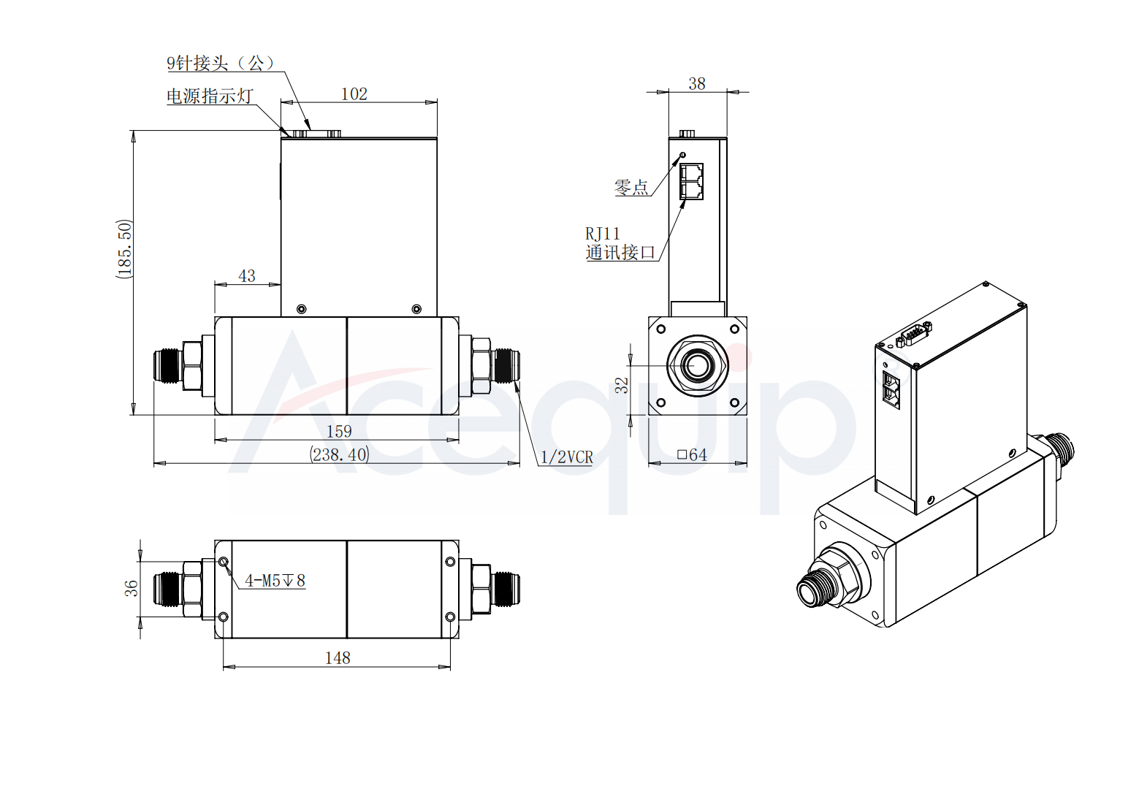

**Part Number Identification（Analog）**

D2 Analog (300-2000 SLM) MFC/MFM

D2-FCRANCV/D2-FCRAVCV

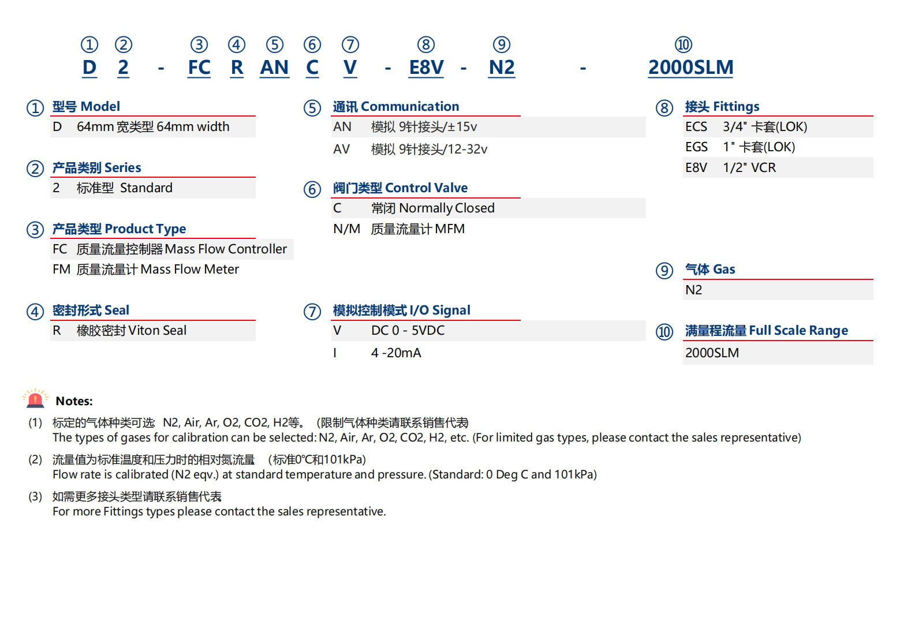

**Part Number Identification（Digital）**

D2 Digital (300-2000 SLM) MFC/MFM

D2-FCRRNCS/D2-FCRRVCS

